
INDIAN INSTITUTE OF FOREST MANAGEMENT, BHOPAL


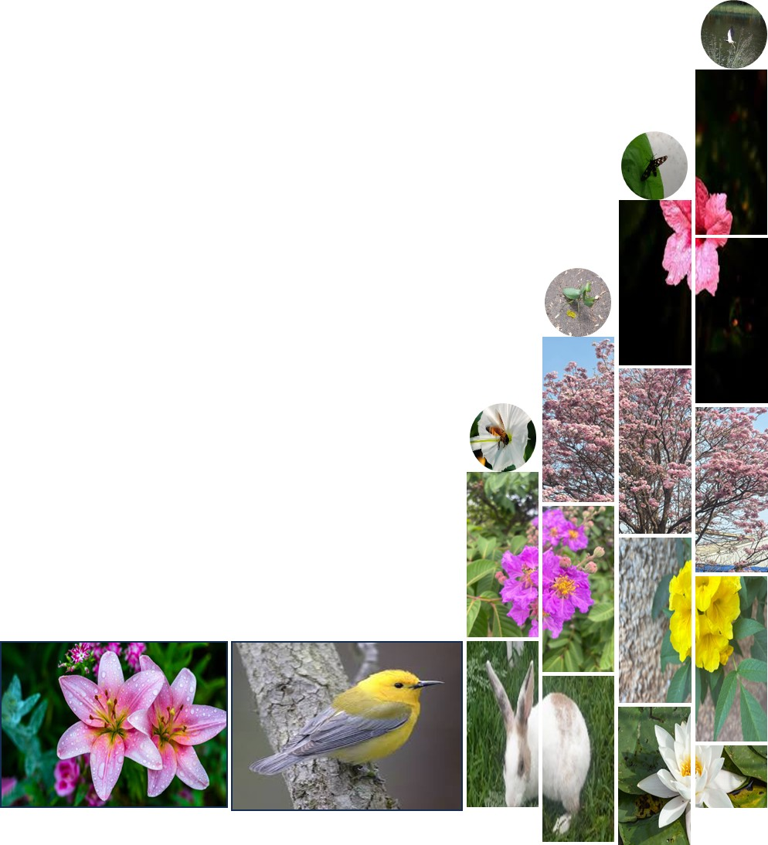
PGDFM’26 Summer Internship 2025 Report
Prepared By,
Name: Radha Krishna Jha
Roll No: 24F044

Under Guidance of,
Reporting Officer: Mr. Madhusudanan K.
Designation: GM (ESG)

Organisation: Ashok Leyland
Project Title
“Biodiversity Risk Assessment”
Report submitted in partial fulfilment of the Post Graduate Diploma in Forestry Management

I. About the organisation 4
II. Declaration by the organisation 5
CONTENTS
III. Relieving/No objection/ No dues certificate 6
IV. Plagiarism Declaration 7
V. Non-Disclosure Agreement 7
1. Acknowledgement 8
2. Executive Summary 9
3. Introduction of project details and organisation 10
4. Literature Review & Benchmarking 15
5. Comprehensive Overview of the Internship Project 21
6. Methodology & Internship Activities 24
7. Results 29
8. Ashok Leyland Biodiversity policy 51
9. Discussions: 54
10. Conclusion 56
11. Reference 57
12. Annexure 58
12.1 Acronyms: 58
12.2 Definitions: 58
12.3 Flora species found inside both the plants: 61
12.4 Fauna species: 63
12.5 Project timeline: 64
12.6 Gantt chart 65
12.7 Key learnings and Takeaways: 66

SI No. | Subject | Page No.
1 | Depicting the history of evolution | 4
2 | Picture showing declaration by Ashok Leyland | 5
3 | picture showing no dues certificate by the organisation | 6
4 | Trucks of AL | 11
5 | Buses of AL | 12
6 | LCVs of AL | 13
7 | Showing PSBs of AL | 13
8 | Showing armoured vehicles of AL used by the army of different nations | 14
9 | Belt transact line & Quadrats | 27
10 | Faunal classified data | 30
11 | Floral classified data | 30
12 | Trend of trees after afforestation programme (2016-2013) | 30
13 | TNFD guideline build on existing framework | 35
14 | Nature-related dependencies, impacts, risks and opportunities | 36
15 | IBAT located KBAs, protected areas and STAR 5 Km. resolution near to AL Hosur plants. | 37
16 | Representing the governance of AL for Biodiversity and environment | 38
17 | Refers to the WWF water risk filter. Showing various risk categories across time | 41
18 | Refers to WWF biodiversity risk filter scape scores | 42
19 | Showing habitat integrity & biodiversity sensitivity through heat map | 44
20 | Monarch butterfly | 46
21 | Hierarchy of risk mitigation | 49
22 | Showing initiatives by AL | 51
23 | showing the transformation from traditional supply chain to green sc. | 51
24 | Showing the 5R process AL is practising | 52
25 | Some snippets taken during data collection | 54
26 | Gantt chart | 64
LIST OF FIGURES

LIST OF TABLES
SI No. | Subject | Page No.
1 | Depicting species frequency | 32
2 | Depicting species relative abundancy | 33
3 | Depicting sum of the individuals | 33
4 | Depicting Log of proportion of individuals | 34
5 | Depicting water risk filter by WWF | 40
6 | Depicting biodiversity risk filter by WWF | 42
7 | Showing parameters of integrity calculation | 46
8 | Dependency heat map matrix | 48
9 | Dependency heat map matrix | 48
10 | showing classification of some species for demonstration through IUCN status & Nativity status. | 60
12 | Showing faunal data according to WLPA,1972 | 62
13 | Project plans charter and timeline | 63

About the organisation
Ashok Leyland, flagship of the Hinduja group, is the 2nd largest manufacturer of commercial vehicles in India, the 4th largest manufacturer of buses in the world, and the 19th largest manufacturers of trucks. Headquartered in Chennai, 9 manufacturing plants gives an international footprint -7 in India, a bus manufacturing facility in Ras Al Khaimah (UAE), one at Leeds, United Kingdom and a joint venture with the Al teams Group for the manufacture of high-press die-casting extruded aluminium components for the automotive and telecommunications sectors, Ashok Leyland has a well-diversified portfolio across the automobile industry. Ashok Leyland has recently been ranked as 34th best brand in India. It is also an ISO 27001:2022 certified company. Pioneers in the Commercial Vehicle(CV) space, many product concepts have become industry benchmarks and norms. Ashok Leyland has ISO/TS 16949 Corporate Certification and is also the first CV manufacturer in India to receive the OBD-II (on board diagnostic) certification for BS IV-compliant commercial vehicle engines, SCR (selective catalytic reduction), iEGR (intelligent exhaust gas recirculation) and CNG technologies. Ashok Leyland is the first truck and bus manufacturer outside of Japan to win the Deming prize for its Pantnagar plant in 2016 and the Hosur Unit II has been awarded the Deming Prize in 2017.

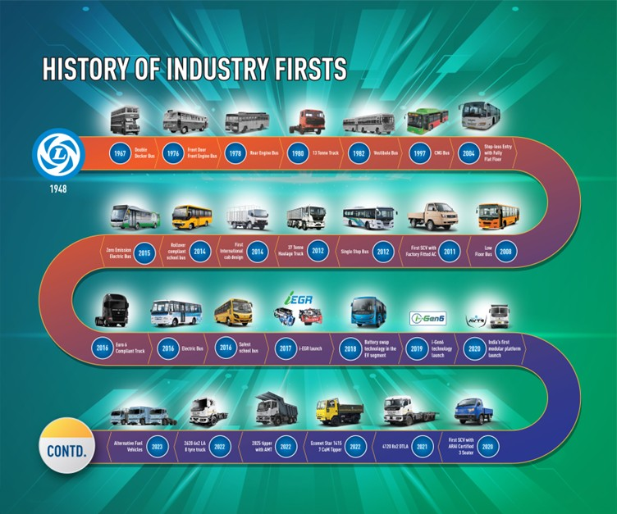

Fig 1: Depicting the history of evolution

Declaration by the organisation
This is to certify that the project entitled, “Biodiversity Risk Assessment for Ashok Leyland” is an original work. This work has been carried out by Mr. Radha Krishna Jha, as summer internship project, in my guidance for the partial fulfilment of Post Graduate Diploma in Forestry Management at Indian Institute of Forest Management, Bhopal.

Name/Signature of Reporting Officer: Madhusudhanan.K
Seal:
Date: 27/06/25
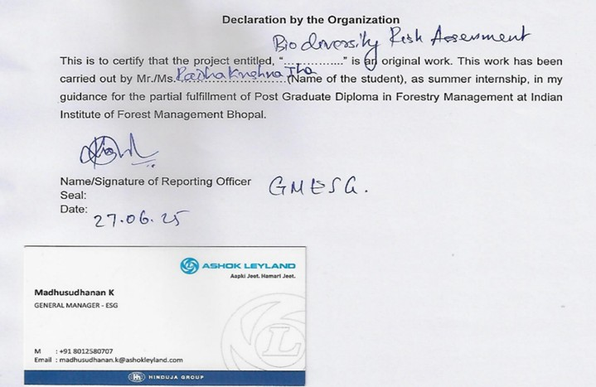

Fig 2: Picture showing declaration by Ashok Leyland

Relieving/No objection/ No dues certificate
This is to certify that Mr. Radha Krishna Jha has successfully completed his Summer Internship as part of IIFM Bhopal course requirement. There are no outstanding dues to be received from him by the company. We wish him all the best for his future endeavours.
Name/Signature of Reporting Officer: Madhusudhanan.K
Seal:
Date: 27/06/25


Fig 3: picture showing no dues certificate by the organisation

Plagiarism Declaration
This is to certify that the report titled Biodiversity risk assessment submitted by Mr. Radha Krishna Jha is an original piece of work. It has not been plagiarized and all sources used have been duly acknowledged. The content is submitted in compliance with the academic integrity guidelines of the institution.


Signature,

Non-Disclosure Agreement
By Ashok Leyland - “All information, data, reports and analysis shared, developed as part of the biodiversity risk assessment project during the internship by Mr. Radha Krishna Jha is confidential property of Ashok Leyland. This confidential information must not be disclosed, reproduced or shared with any third party or institute without prior consent. Any academic report to the institute must exclude AL data.”
In strict compliance with the Non-Disclosure Agreement (NDA) signed with Ashok Leyland, this report meticulously upholds all confidentiality and privacy obligations as stipulated. No proprietary information, sensitive data, internal documents, or confidential facts pertaining to Ashok Leyland have been used, disclosed, or referenced. The scope of this report is exclusively limited to describing the tasks assigned and completed during the internship period at Ashok Leyland.
Consequently, the outcomes presented are strictly visual in nature, with no interpretive conclusions drawn or analyses conducted that could relate to Ashok Leyland’s practices, manufacturing methods, operational strategies, or any other internal or proprietary areas of the organization. All images used within this report that depict Ashok Leyland facilities have been sourced from publicly available platforms, ensuring that no restricted photographs have been included.
This approach guarantees that the contents of this report fully align with the confidentiality requirements established in the NDA, while providing an accurate and faithful depiction of my learning experience and work conducted at Ashok Leyland.
Name/Signature of Reporting Officer: Madhusudhanan.K

Seal:
Date: 27/06/25

Acknowledgement
I extend my heartfelt gratitude to the Indian Institute of Forest Management (IIFM), Bhopal & Ashok Leyland (Flagship of the Hinduja group) for providing me with an exceptional opportunity to engage in a transformative summer internship experience. The institute's commitment to fostering a holistic learning environment has been instrumental for me. I am also extremely grateful to the entire team of Ashok Leyland for their continuous cooperation and invaluable guidance. This experience has not only enhanced my technical skills but has also instilled in me a deeper appreciation for the importance of biodiversity in corporate operations. I am incredibly grateful for the opportunity to work with Mr. Madhusudhanan.K, GM ESG & Venkatraman S., AGM EHS at Ashok Leyland, for his constant guidance, encouragement, and support throughout 9 weeks tenure of my internship. Their expertise, mentorship, and willingness to share knowledge have been invaluable in shaping my understanding of biodiversity & Impact assessment practices in the context of a dynamic industry of heavy equipment manufacturing. I would like to take this opportunity to extend my heartiest gratitude to our respected Professor – Dr. Yogesh Dubey, whose guidance was everything beyond my thoughts. He contributed to making my SI at Ashok Leyland a rewarding and enriching experience. I am also indebted to the efforts shown by our SI head Dr. Anand Hindolia, without whom the entire structure and stability of my SI would have collapsed. I would also like to express my sincere appreciation for the tireless efforts undertaken by the faculty, staff and administrative team of IIFM, Bhopal, for providing me with the context of knowledge which has continuously helped me in during the process while I was undergoing this internship, it would have not been possible without their continuous support and encouragement. In the journey of completing this internship, I have always been profoundly grateful to my family and friends whose unwavering support, encouragement, and understanding made it possible. As I present this report, I recognize that it reflects the collective commitment, passion, and hard work of everyone involved. I am truly grateful for the collaborative environment fostered by both the institutions.

Radha Krishna Jha,
24F044
PGDFM (2024-26)

Executive Summary
This report encapsulates the comprehensive activities and assignments undertaken during Nine weeks internship at Ashok Leyland, contributing significantly to the company's Environmental and sustainability initiatives. The primary focus was on developing a robust report indicating the risks to and from the organisation on the biodiversity around and inside the premises, aligning with global best practices and standards. Further, a comprehensive primary data collection was done in two plants at Hosur, Tamil Nadu, considering the Floral, Faunal and surrounding ecosystem conditions and the whole data set was aligned with WPA,1972 (2022 amendment) & IUCN red list category. The presence of 160+ schedule I and Ⅱ species of fauna according to WPA,1972 (2022 amendment) of India and 300+ species of flora according to IUCN red list category were recorded, indicating a moderate to high biodiversity richness. The species richness, (calculated through Shannon-weiner index), evenness of species, homogeneity, abundancy and frequency were analysed for the tree species present inside the proposed area. Aligned with TNFD and WWF risk filter, Primary risks, opportunity, impacts and dependency were identified. Risk levels were categorized using a standardized scoring system, statistical data were analysed to ensure the habitat integrity and biodiversity sensitivity approximation. Mitigation measures, aligned to GRI disclosures, such as greenbelt development, pollution control plan, and biodiversity offsets are developed. Benchmarked Ashok Leyland’s biodiversity policy and work with various globally established organisations and found the loopholes in their operations and prepared plans and policies to mitigate risks. Engaged with internal departments to discuss the importance and benefits of biodiversity Rating by DJSI and their requirements through questionnaire assessment available on the website. Developed a roadmap for aligning the tasks with the TNFD and DJSI guidelines, along with various other smaller assignments. The activities and assignments undertaken during this internship have significantly advanced Ashok Leyland’s sustainability related initiatives and provided valuable insights and recommendations for future improvements. This experience has enriched my understanding of biodiversity practices and their integration into business operations, contributing meaningfully to AL’s environment positive journey.
By addressing these policy gaps and implementing the proposed recommendations, India can make significant strides towards achieving sustainable development and improving the manufacturing industry efficiency and environmental stewardship.

AL biodiversity and No deforestation policy

Please note that due to confidentiality, some detailed analyses and data could not be included in this report.

Introduction of project details and organisation
The project details for this internship at Ashok Leyland were crucial for understanding the goals, scope, and expected results of the biodiversity risk assessment. These details provided guidance for connecting the work with the organization’s sustainability and environmental conservation plans. The team has supported informed decision-making, encouraged good communication, and served as a helpful reference for future projects. In short, the project details were essential for maintaining clarity and relevance during the assessment process, which greatly contributed to its success and lasting impact.
- Project title: “Biodiversity Risk Assessment for Ashok Leyland.”

- Purpose: To evaluate the biodiversity status at Ashok Leyland’s facilities and nearby areas, the focus was on identifying native and invasive species, checking habitat conditions, understanding ecological impacts and drafting the report for public disclosure and identifying the critical risks, dependency, impacts and opportunities to the organisation. The project aimed to review current conservation efforts, look at site-specific biodiversity data, and suggest steps to reduce biodiversity loss. It also intended to connect these efforts with global best practices and the organization’s environmental sustainability goals.

- Objectives: Under this project, major objectives were achieved:

  - Conducting a comprehensive biodiversity risk assessment for Ashok Leyland’s facilities.
  - Quantify Species Diversity: Exhibit the calculated biodiversity richness & species diversity for flora and fauna, leveraging the Shannon-Wiener Index to present a solid ecological baseline.
  - Identification of risk, opportunity, impact & dependency: Illustrate the systematic execution of the Taskforce on Nature-related financial disclosures (TNFD) LEAP approach & WWF Risk filter recognizing and evaluating nature-related dependencies, impacts, risks and opportunities.
  - Measure Biodiversity Loss Drivers: Identify and quantify the regional fragility indicators and primary drivers of biodiversity decline, such as habitat conversion and hydrological stress, through specific nature pressure metrics.
  - Present the Habitat integrity and homogeneity status of species present- To calculate and present the habitat integrity score and homogeneity status of species present in the proposed area.
  - Outline Mitigation Hierarchy Application: Report Ashok Leyland's adherence to the GRI aligned mitigation hierarchy for biodiversity and align these strategies with the proposed policy of AL.
  - Demonstrate Net Positive Alignment: Showcase the alignment of AL’s operational impacts with commitments towards achieving net positive biodiversity outcomes by 2030.
  - Proposing actionable recommendations and presenting the biodiversity management plan for habitat enhancement and aligning biodiversity conservation practices with national and international standards.

- Scope: The project “Biodiversity Risk Assessment for Ashok Leyland” sought to incorporate strong ecological care into the organization’s operational and environmental goals. The scope included identifying and listing plant and animal species in the site area, assessing habitat quality, and evaluating threats from invasive species or industrial activities. The project featured extensive site walks, data collection, stakeholder consultations, and a review of existing environmental policies. Key focus areas included creating site-specific conservation recommendations, ensuring biodiversity policies matched national regulations and international best practices, and suggesting practical steps to reduce ecological impacts. The initiative also stressed building the team’s skills and supported long-term monitoring and reporting for ongoing improvement. Through this project, Ashok Leyland aims to promote environmental care, maintain ecological balance, and support sustainable growth while aligning its operational practices with global standards. Biodiversity risk assessment at Ashok Leyland’s Hosur Units I and Ⅱ establishes an essential ecological baseline. Situated within a dynamic regional landscape with plethora of biodiversity, the study diligently described widespread flora and fauna, alongside foundational ecosystem health parameters. Focused analysis of water pH, soil moisture and pH provided initial insights into the abiotic factors crucial for ecological integrity.

- Product details: In the world of heavy automobile manufacturing Ashok Leyland, a flagship of Hinduja group, establish itself as the leading organisation. It spread its footprints from India to Middle east of Asia and Europe. It has total of 7 manufacturing plants in India, in which 2 is in Hosur (Tamil Nadu), Pantnagar (Uttrakhand), Alwar (Rajsthan), Ennore (Tamil Nadu), Bhandara (Maharastra), Vijaywada (Andhra Pradesh). They manufacture Trucks, Bus, LCV, PSB, Defence vehicles and others. Some of their products are as below:
- Trucks: These are the heavy lifter of loads with various variants in 39L, 42.5L, 46L, 34.5L and many more. AL is one of the largest manufacturers of these vehicles with variant in designs from their body part to others. Trucks are used by many industries mostly in construction and supply chain sectors. These are equipped with robust engines, AL trucks deliver high performance and productivity on various job sites.
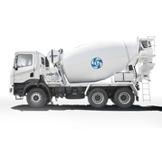



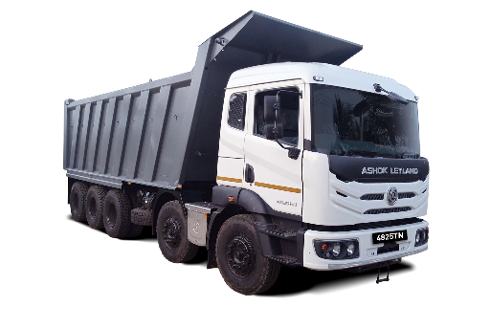


Fig 4: Trucks of AL
- Buses: Ashok Leyland manufactures a diverse range of buses designed for urban transportation, staff and school commutes, and long-distance intercity travel. These buses are built to be highly reliable, safe, and comfortable, making them ideal for daily commutes and longer trips. They can operate on various fuel options, including diesel, CNG, and electric, making them a popular choice for both traditional and eco-friendly transport. Ashok Leyland buses are available in different seating capacities ranging from 12 to 60 seats, with options for low-floor, semi-low-floor, and high-floor designs, ensuring accessibility and comfort for all passengers. The company offers a range of engine options from H-Series and N-Series diesel engines with outputs ranging roughly from 100 to 250 horsepower, as well as electric motors for its electric bus range. Depending on the model, the Gross Vehicle Weight (GVW) can range between 6 and 18 tons. These buses feature modern amenities such as air suspension for enhanced comfort, anti-lock braking systems (ABS), GPS tracking, telematics for route optimization, climate control, and other safety features. From city buses like JanBus and Oyster, to staff and school transport options like MiTR and Sunshine, and long-haul coaches like Viking and Oyster Premium, Ashok Leyland delivers reliable, cost-efficient, and sustainable mobility solutions across a range of transport needs.



Fig 5: Buses of AL
- LCV goods carrier: Ashok Leyland's line of LCV goods carrier vehicles is designed to offer efficient, reliable, and cost-effective solutions for businesses of all sizes. These vehicles are great for transporting various goods, including perishable items, construction materials, and consumer products. They are popular in both urban and rural areas. Built for durability and flexibility, Ashok Leyland LCVs come in different payload capacities, usually ranging from 1 to 7 tons. They feature dependable diesel and CNG engine options that provide a good balance of performance and fuel efficiency. The engine outputs range from 60 to 130 horsepower, delivering plenty of pulling power and smooth drivability, even on tough terrains. These vehicles have several load body options, such as fixed, high-side, and custom-built bodies, making them suitable for different applications. They include safety and comfort features like power steering, anti-lock braking systems, and ergonomically designed cabins, ensuring a safe and pleasant experience for the driver. Known for their strong build quality, low maintenance costs, and long service life, Ashok Leyland LCV goods carriers help businesses improve their logistics operations while lowering overall costs and supporting sustainable growth.
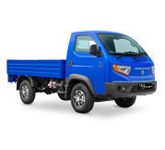
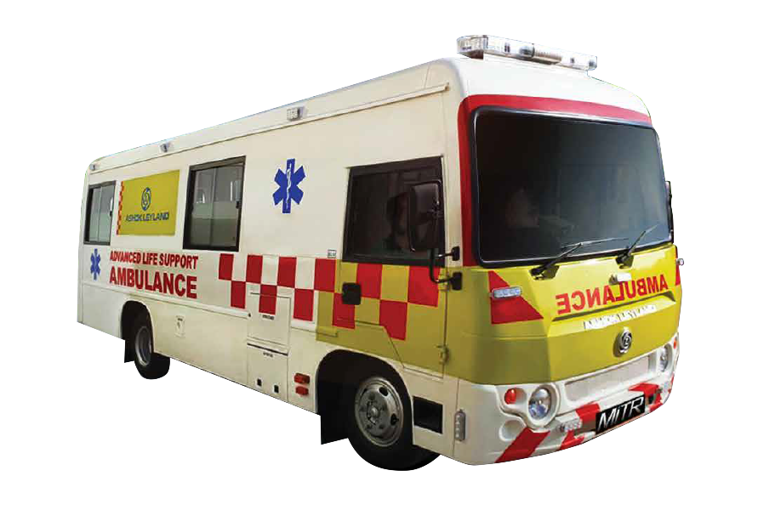
Fig 6: LCVs of AL

- PSB: Ashok Leyland’s Power Solutions Business (PSB) offers robust, fuel‑efficient diesel and CNG engines and gensets for industries like construction, agriculture, and manufacturing, providing reliable, low‑maintenance, cost‑effective, and seamless power in challenging environments.
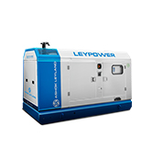
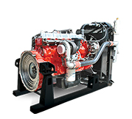Fig 7: Showing PSBs of AL

- Defence armoured vehicles: Ashok Leyland develops rugged, versatile defence vehicles designed for challenging terrains and harsh conditions, including troop carriers, logistics trucks and armoured platforms. Renowned for reliability, durability, and advanced engineering, these vehicles support military operations with superior performance and safety.










Fig 8: Showing armoured vehicles of AL used by the army of different nations

Note: For more visit Ashok Leyland’s website

Literature Review & Benchmarking

- Mahajan and Fatima (2017) examine species richness and diversity on the Fergusson College campus in Pune. They highlight its varied nature and different compositions. Using a systematic approach with the list-count quadrat method, the study identifies 40 herbaceous species. It also looks at their frequency, abundance, and density across ten quadrats. The authors connect their findings to Raunkier’s classification. They show that the site includes species from all five frequency classes, with a higher dominance in the “E” category. This suggests a well-distributed and diverse plant community. The study stresses the importance of assessing species richness and abundance as indicators of ecological structure. This aligns with earlier studies that highlight their key role in understanding plant community dynamics (Mahajan & Fatima, 2017).

- Jeffrey J. Opperman, Rafael R. Camargo, Ariane Laporte-Bisquit, Christiane Zarfl, and Alexis J. Morgan's 2022 work, "Using the WWF Water Risk Filter to Screen Existing and Projected Hydropower Projects for Climate and Biodiversity Risks," introduces the application of the WWF Water Risk Filter as a crucial tool for assessing climate and biodiversity-related risks associated with hydropower projects. Opperman et al. (2022) emphasize the necessity of proactively identifying and mitigating these risks to enhance the sustainability and resilience of hydropower infrastructure, especially given the increasing impacts of climate change on water resources and ecosystems. The authors detail how the Water Risk Filter can be utilized to screen both existing and planned hydropower projects, providing a systematic approach to evaluate various risk categories, including physical, regulatory, reputational, and financial aspects related to water. This tool facilitates better decision-making by enabling stakeholders to understand potential environmental impacts and identify opportunities for more sustainable water management practices within the energy sector.

- An Introduction to Line Transect Sampling and Its Applications (Bright Owusu, 2019) and emphasizes that line transect sampling is an important method of distance sampling to estimate animal and plant populations abundance and density, when collecting ecological data and for ecology studies. Owusu (2019) explains that line transect sampling was first initiated in the 1930s, by R.T. Kingston. Line transect sampling uses the perpendicular distances of detected objects to calculate density and abundance using a detection function that determines the extent of detectability; as one moves farther from the transect, potential detection decreases. In his study, Owusu (2019) outlines how to randomly place one or multiple transects and use model selection methods such as Akaike Information Criterion (AIC) and goodness-of-fit tests for model selection based on detection function models, and in R, estimate density and abundance using the program Distance. In a simulation study of the longleaf pine trees; Owusu (2019) discusses how detection function models (Half-normal, Hazard-rate, and Uniform with cosine adjustment) can all be used to create a detection function, and how the model and parameters that were chosen (or not) may lead to a low abundance, or higher abundance by either estimating low abundance or estimating high abundance. Importance of the line transect model assumptions is highlighted so that all information is used efficiently, and better abundance values can be realized.

- The TNFD LEAP (2023) approach comprises an expansive framework with recommendations for understanding nature and evaluating impacts on nature, including the impacts on species richness and diversity in ecosystems. It highlights that biodiversity - the variability among living organisms, as well as the ecosystems where they occur, and now including a variability across land, ocean, freshwater, and atmosphere is a vital part of nature and an important contributor to ecosystem resilience and productivity. TNFD (2023) establishes that biodiversity or species richness and diversity is the basis upon which the health of ecosystems is grounded, as species illustrate the ability of ecosystems to withstand pressures or opportunistically or creatively adapt. This include all of the ecosystem services we so dearly rely upon as humanity - pollination, climate regulation, water purification, nutrient cycling, etc. TNFD (2023) proposes a LEAP approach that facilitate organisations to evaluate their own dependencies and impacts on species and habitats by locate their interfaces with nature, assess direct and indirect impacts, and prioritise areas for action. This shifts the conversation about species richness and diversity to a more robust understanding as measures for understanding nature-related risks and opportunities, framed to meet corporate strategy with global biodiversity conservation.

- The Wildlife (Protection) Act, 1971 (Amended 2022) provides the legislative platform for the conservation of species richness and diversity in protected areas in India. The Act recognizes the importance of habitats as the "natural home of any wild animal" (WLPA 2022), and designates sanctuaries, national parks, conservation reserves, and community reserves as a way to preserve the ecological and zoological significance of habitats to maintain species richness. The Act seeks to conserve biological diversity, protect threatened species from further decline, and to promote recovery of species through the listing of species in Schedules and prohibiting their hunting, or taking of wildlife. The provisions to promote species-specific measures, habitat protection and area-based conservation reflect a holistic strategy to help maintain species richness and the ecological balance necessary to safeguard India's unique wildlife legacy (WLPA, 2022).

- Quadrat sampling, a basic utilized approach for gauging species richness and abundance and by nature of the definition, a standardized option for use in vegetation studies (Baxter). In Baxter's words, it enables the researcher to record the occurrence of species and measure abundance on a given defined unit, making it an effective choice through a variety of vegetation types, from mosses and forbs to shrubs and trees. Quadrats give valuable metrics like cover, density and frequency or availability, and when availability or density are linked together, you may be able to ascertain an Importance Value (IV) of each species which lets you see the overall importance of a species within an ecological context (Baxter). Moreover, Baxter outlines the range of benefits with stratified random sampling, which is when the study area is divided up into layers according to some aspect of topography, an aspect or some floristic sample, to give a more representative and honest picture of the species richness and diversity of a habitat.

- In ecological studies, density is a basic measure that reflects the number of individuals of a species per unit area (NCERT). The NCERT Laboratory Manual for Biology states that density provides information about the competitive ability, reproductive potential, and distribution of species in plant communities. The manual describes the quadrat method as a good method of estimating the density of plants and recommends using ten quadrats randomly placed in the study area to measure the number of individuals of each species. For plant density, the density is determined by counting the number of individuals of a species in all ten quadrats, dividing by the total number of quadrats, to obtain the average number of individuals per unit area. The manual notes that density estimates are useful for determining the ecological relationships of plant communities such as species composition, competition, and how plants respond to environmental change.

- Density forms a pivotal parameter for assessing species richness and understanding the structure of ecological communities. The Biodiversity Assessment and Carbon Sequestration Report conducted for Dr. Reddy’s Laboratories, Pydibhimavaram, highlights the use of the quadrant method for estimating plant population density across varied habitats (Vizag Biodiversity Report, 2022). In this approach, a 10m x 10m area was randomly selected to assess trees, while smaller quadrats were used for shrubs and herbs. The study followed the standard ecological method where total numbers of individual species across all sample units were summed and then divided by the total number of sample units, yielding the species density (Vizag Biodiversity Report, 2022). This approach allows for a quantitative assessment of the species’ ecological significance within the area. The report further emphasizes the role of density as an index for understanding the competitive dynamics, establishment, and overall health of plant species across habitats, making it an integral tool for assessing and managing biodiversity.

- The Biodiversity Risk Assessment Technical Standard (Mahindra Auto and Farm, 2023) emphasizes the importance of assessing species richness and diversity both for ecological health and as markers for constructing corporate biodiversity and biosphere management. The standard uses, the mitigation hierarchy, avoidance, minimization, restoration, and offsetting to connect operational procedures of companies, seeking to comply with the goal of achieving No Net Loss of biodiversity. According to the standard, species richness and diversity are the platform for understanding the impacts that company activity may have on diverse habitats and landscapes. The standard places an emphasis on baseline studies of the map of habitats, assessment of rare and endangered species, and the assessment of species richness and evenness as measured by the Shannon-Wiener Index (Shannon & Wiener, 1963), and by further analysis of species abundance and dominance (Curtis & McIntosh, 1950). The technical standard also calls for site-specific Biodiversity Management Plans, restoration of native habitats, and ongoing monitoring of richness and composition of species. It is noted that species richness and diversity are not only means of determining a level of ecological resilience, but they are also indirect metrics of company impact, or long-term impact guidance, or important guides for directing restoration and persistence of habitats, inside and outside of the operational footprint.

- The Biodiversity Impact Assessment (BIA) of the mining location in Lumshnong, East Jaintia Hills, presents sufficiently robust information on species richness and diversity, within the core and buffer zones (BIA Report, 2023). It uses acceptable ecological survey methods, which include quadrant and line transect surveys to assess species' distribution, abundance, and density on the impacted site. The report explains that species were reported based on their identification, and counted, across randomly placed 10×10 m quadrats and line transect of 500 m in length. The report notes the species richness and diversity showed the presence of various native and endemic species prevalent within the habitats examined, demonstrating the site's ecological importance still exists in an active mining context. The core zone was a sparsely vegetated area with Terminalia catappa, Toona ciliata, and Artocarpus heterophyllus as dominant species and while there was a lack of species richness due to the disturbance of the site, the buffer zone included the Narpuh Reserve Forest as well as records showing an increase in species richness with a variety of species in the different habitats represented, namely tropical evergreen forest, moist deciduous forest, and subtropical forest (BIA Report, 2023). The BIA also notes to consider species’ frequency, density, abundance and again the Important Value Index (IVI) to quantify and compare species' richness across habitats.

- CCEP highlights the value of species richness and diversity as key components to securing long-stay protection for biodiversity, natural capital, in their global supply chains for long-term ecological resilience and sustainability (CCEP, 2024). With its biodiversity stewardship approach, CCEP is conservatively integrating biodiversity as an operational (n.b. managing biodiversity) and sourcing (n.b. measuring and accounting for nature) into its business plans and practices within the framework of Science Based Targets (i.e. SBT), thus acknowledging the need to measure and disclose nature-related impacts. In cooperation with The Coca-Cola Company, CCEP is leveraging the SBT framework to measure the nature-related impacts of its value chain, identify areas of priority habitats and species, and most notably actions to restore our impact on the terrestrial and aquatic environments it operates in. CCEP understands that species richness and diversity are critical to functional ecosystem services (e.g. water purification, carbon sequestering, flood protection, and habitat quality and provision). These ecosystem services will factor into CCEP’s long-term organisational resilience. CCEP will provide a systemic impact through sustainable agricultural practices, forest protection policies, access to water and targeted water stewardship policies, all aimed at both limiting biodiversity loss and supporting species recovery in the operational landscapes of CCEP's interventions, while also linking and aligning with corporate sustainability and global biodiversity priorities.

- UltraTech Cement Limited has undertaken a comprehensive biodiversity assessment, aligning its efforts with the recommendations of the Climate Disclosure Standards Board (CDSB). UltraTech's approach includes a robust governance framework, where the Risk Management & Sustainability Committee oversees biodiversity management, and Biodiversity Management Plans (BMPs) are implemented and monitored across its units, with a "No net loss" target by 2050. The company's environmental policies and strategies are shaped by materiality exercises and stakeholder engagement, while risks and opportunities are assessed using tools like the Ecosystem Services Review (ESR) and the Integrated Biodiversity Assessment Tool (IBAT). UltraTech also tracks various biodiversity impact indicators, establishes baselines for improvement, and categorizes species using IUCN classifications to inform action plans. The company's outlook considers the future effects of biodiversity impacts and integrates scenario analysis from its TCFD report to inform its strategy.

- BS ISO 31000:2018, as a British Standard implementation of ISO 31000:2018, provides comprehensive guidelines for risk management, superseding the 2009 version. This publication serves as a foundational reference for organizations seeking to integrate risk management effectively across all their activities and decision-making processes. The standard, developed with the participation of the UK's Technical Committee RM/1 on Risk Management, emphasizes principles, framework, and process for managing risk, rather than prescribing a specific methodology, allowing for adaptability across diverse organizational contexts and complexities. It aims to help organizations increase the likelihood of achieving objectives, improve the identification of opportunities and threats, and effectively allocate and use resources for risk treatment.

- GRI 101: Biodiversity 2024, published by the Global Sustainability Standards Board (GSSB) is an important Topic Standard that will be effective for reports or similar materials, published on or after January 1, 2026. This standard has been developed in the public interest, through a multi-stakeholder consultative process following the GSSB Due Process Protocol and taking into consideration relevant authoritative intergovernmental instruments and widely-held expectations for environmental responsibilities to guide the development of the most relevant and appropriate set of guidance for organizations to report their impacts on biodiversity and nature- by creating transparency and comparability of disclosures on nature-related impacts by providing direct emphasis on direct drivers of biodiversity loss, such as, land and sea use change, exploitation of natural resources, and water withdrawal, among other drivers of biodiversity loss.

- Melville and Welsh (2001) provide a comprehensive methodological framework for estimating species abundance by treating organisms as points distributed according to spatial point processes, distinguishing between design-based approaches (randomness from sampling schemes) and model-based approaches (randomness from underlying stochastic processes). The authors examine various spatial models from simple homogeneous Poisson processes to complex alternatives including inhomogeneous Poisson, inhibition models, and the Strauss process, demonstrating model identification complexity by showing how negative binomial distributions can arise through multiple mechanisms. For quadrat sampling, they present classical estimators (expansion, ratio, and Horvitz-Thompson) for design-based approaches and examine Poisson, binomial, and negative binomial models for model-based approaches, providing practical guidance on quadrat size selection with mean count rules of 1.0-4.0. They introduce adaptive cluster sampling for rare, clustered populations using two-stage sampling with initial probability sampling followed by adaptive expansion, while also covering distance sampling methods and capture-recapture techniques. Throughout their review, Melville and Welsh acknowledge both methodological achievements and limitations including difficulty distinguishing between spatial processes, model uncertainty, and challenges with mobile species, ultimately providing a unified theoretical framework bridging statistical foundations with practical ecological applications.
- IUCN Net Loss Principal Document: The IUCN Net Loss principal document provides guidance on achieving no net loss in biodiversity, which can be integrated into Ashok Leyland’s ESG strategy:
1. Biodiversity Mitigation: The document outlines strategies for mitigating biodiversity impacts, such as habitat restoration and conservation efforts. Ashok Leyland can adopt these strategies to minimize its environmental footprint and enhance biodiversity conservation.
2. Baseline Biodiversity Metrics: Establishing baseline biodiversity metrics is crucial for tracking progress towards no net loss. Ashok Leyland can use these metrics to assess the impact of its operations on local ecosystems and implement measures to mitigate adverse effects.
3. Stakeholder Collaboration: The principle emphasizes the importance of collaborating with stakeholders, including local communities, government agencies, and NGOs, to achieve biodiversity goals. Ashok Leyland can foster such partnerships to enhance its conservation efforts and gain broader support for its initiatives.
- DJSI (CSA) Framework: The Dow Jones Sustainability Index, through the Corporate Sustainability Assessment (CSA), evaluates companies based on a comprehensive set of ESG criteria:
1. Disclosure Requirements: The CSA requires extensive disclosures on economic, environmental, and social dimensions. This includes governance practices, risk management, climate strategy, labour practices, human rights and community impact.
2. Focus Areas: The DJSI framework places a strong emphasis on integrating sustainability into core business operations and strategy. It covers a wide range of topics, ensuring a holistic assessment of a company's sustainability performance. Ashok Leyland can benefit from this comprehensive approach to address all aspects of its ESG performance.
3. Scoring and Reporting: The CSA uses a detailed scoring methodology that evaluates the depth and quality of sustainability practices and disclosures. Companies receive scores across various criteria, which are then aggregated to form an overall sustainability score. This provides a nuanced understanding of a company’s ESG strengths and areas for improvement.













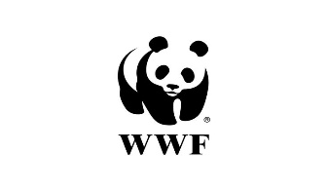

Comprehensive Overview of the Internship Project
The initiative Biodiversity Risk Assessment for Ashok Leyland is an example of assessing biodiversity impacts while aligning with conservation in the workplace, including global standards which further enhances organizations duty of care regarding sustainability. This project aims to achieve two primary objectives: the assessment of a Biodiversity Risk Assessment across Ashok Leyland's Audiences and the alignment of Ashok Leyland’s biodiversity conservation practices to include internationally recognized policies which include the International Union for Conservation of Nature (IUCN) and Convention on Biological Diversity (CBD).
Ashok Leyland associated use objectives of the project with the use of a shared and comprehensive Biodiversity Risk Assessment Framework that was developed specifically for the manufacturing units and surrounding areas of Ashok Leyland. This approach provides an opportunity for Ashok Leyland, as a unified body to monitor and account for all ecological indicators and catalogue any threats to local habitats or species. Furthermore, it provides stakeholders with data to act on and informed decisions taken, while providing opportunities for continuous improvement and re-evaluation of the biodiversity management.
The second objective focused on the alignment of Ashok Leyland’s biodiversity policies, and conservation practices in line with international best practice. Through the application of standards measures under IUCN, CBD, and other international guidance the Company can better measure, report and disclose biodiversity actions taken and kept informed, accountable and transparent to internal and external stakeholders.
The process used to do the Biodiversity Risk Assessment, drew in numerous data points from a number of departments, observations from sites across Asok Leyland facilities. Species richness, habitat conditions, areas of potential threat, and ecosystem health were some of the metrics identified for the assessment framework. More recently, GIS and analytics could be used along with the assessment information to visualize the findings and lead site management and sustainability practitioners towards informed actions.
Ashok Leyland's biodiversity policies, and conservation practices were first collated and considered, revised, and benchmarked to provide seamless alignment with global standards. Additionally, this phase included conducting a gap analysis, our experts contributions and stakeholder inputs, and aligning our internal policies and actions to the United Nations Sustainable Development Goals (SDGs), IUCN Red list along with local and national legislation around biodiversity and the environment.
The implementation of the Biodiversity Risk Assessment and the alignment of conservation policies have significantly enhanced Ashok Leyland’s ability to measure, manage, and mitigate its impacts on local ecosystems. The availability of credible data and actionable insights allows the company to adopt a more proactive approach in biodiversity conservation and operational planning, leading to a reduced ecological footprint and improved environmental resilience.
By aligning its biodiversity practices with global standards and committing to continuous improvement, Ashok Leyland has strengthened its role as a responsible corporate citizen in the automotive sector. Investors, customers, employees, and regulators can now access credible, transparent information about the company’s efforts to protect biodiversity, fostering trust and reinforcing its reputation as a sustainability-focused brand.
The successful implementation of the “Biodiversity Risk Assessment” project marks a pivotal step in Ashok Leyland’s journey towards ecological sustainability. By leveraging data-driven assessments, international best practices, and stakeholder engagement, Ashok Leyland has laid a strong foundation for long-term biodiversity conservation and responsible growth within its operational landscapes.

Operations at Ashok Leyland:
As a key player in the commercial vehicle industry, Ashok Leyland has a well-established and effective business model that includes numerous operational aspects. The manufacturing process across India is based on advanced engineering, precise manufacturing, quality and safety and sustainability. To take advantage of the benefits of its state-of-the-art facilities and automation, Ashok Leyland manufactures a large number of commercial vehicles-trucks, buses, light commercial vehicles (LCVs) and special applications for an ever changing domestic and international marketplace.
Manufacturing at Ashok Leyland involves a variety of steps, starting with planning and sourcing high-quality raw materials from suppliers with whom Ashok Leyland has established relationships. The production units use advanced machinery, automated production and assembly, and lean manufacturing to optimize, minimize, and maintain precision during all stages of fabrication and assembly. Quality and testing are included throughout the entire Ashok Leyland production cycle to ensure that you receive an Ashok Leyland vehicle that meets or exceeds some standards for performance, durability, and reliability.
Ashok Leyland's methods and production reflect an integrated combination of engineering capability, technological progress, sustainability and mobilization of resources that exemplifies it as a leader in the automotive marketplace. The focus on responsible resource use, strong supply chain, and process excellence allows its products to continue to advance industries and communities. In other words, Ashok Leyland operates at multiple levels concerning designing, manufacturing and delivering high quality, efficient and reliable commercial vehicles. Clarity of precision-engineering, sustainable manufacturing and effective collaboration enables Ashok Leyland to continuously produce best-in-class transportation solutions that meets customer requirements, complies to international quality standards and understands how to drive the quality benchmark of the automotive industry. Through its focus on customer satisfaction, ongoing innovation, and sustainable mobility, Ashok Leyland is shaping the future of transportation and making a significant contribution to economic and social growth.
The company’s efforts extend beyond manufacturing to encompass after-sales support, service quality, and long-term value creation for its customers and stakeholders. Its strong heritage, combined with a forward-looking mindset, allows Ashok Leyland to adapt to evolving market dynamics, regulations, and environmental demands. In doing so, it not only delivers dependable transportation solutions but also promotes safer, cleaner, and more efficient mobility across communities.

Engine Unit Transmission Unit Fabrication Unit

Assembly of vehicles

Inspection


Dispatchment of vehicles/motors

Methodology & Internship Activities
After benchmarking with the aforementioned companies and finding out the gaps in their operations and towards biodiversity, I made various key takeaways from their reports then I started to study the methodologies for the biodiversity risk assessment to integrate it in AL’s report. That gave me a robust idea of how to approach further with variety of data we collected from the field. Here is the list of activities that I performed at two units of AL in Hosur to complete the biodiversity risk assessment:
- Assessment of the Key biodiversity zones inside the campus: On the very first day of my plant visit, I conducted an extensive site survey across the campus to understand its rich biodiversity. I visited the areas with very high abundance of flora and fauna, carefully noting the diversity of species and their habitats. These initial observations gave a clear picture of the site’s ecological richness and served as the foundation for a more structured approach to the biodiversity assessment. It was evident that certain areas harboured a greater variety of native trees, shrubs, and wildlife, making them key focus points for further study. Based on these observations, I divided the campus into distinct Key Biodiversity Zones (KBZ) to enable targeted monitoring and conservation efforts. Unit 2 in Hosur was divided into eight KBZs similarly Unit 1 was divided into five KBZs. This zoning approach allowed for a more detailed, organized, and focused assessment of species richness, habitat quality, and ecological interactions across the campus, facilitating a strong baseline for future conservation and management activities at Ashok Leyland.
Our team has carried out the assessment in two parts, id est., Biodiversity and Ecosystem surrounding it. The biodiversity assessment has been carried out in two parts for Fauna and Flora. The survey was conducted for about 12 days in Hosur unit 2 and for about a week in Hosur unit 1. All the Flora sampling were taken once in a day. But Fauna samplings were taken twice a day, once in the morning at 5’o clock (early morning) and second in the evening at 6’o clock (late evening) in both the plants. All the flora species, fauna species, their surrounding ecosystem, Noise levels, water PH, Soil Ph and waterbodies are assessed thoroughly to get valuable information related to the biodiversity and threats associated from the surrounding environment, whether it’s Manufacturing unit operations or ecosystems own challenge, on them. Standard protocols and regulations have been followed in the assessment of the biodiversity inside the plant vicinity.

- Floral data collection: The manufacturing plants mentioned above are located in southern part of India, which are having plethora of tropical dry deciduous forests and deccan thorn scrub forests. Beside this the area also caters some of the moist deciduous trees with broad leaves, mostly located near water sources, which are native of western and eastern ghats of India. Whole plant was delineated with 13 biodiversity zones respectively on observational basis on the very first day. Where cornucopia of floral and faunal diversity observed. The study employed a deliberate Quadrat sampling method for Floral assessment. Where Nested quadrats of 10×10 m was drawn for the floral diversity assessment. The assessment consisted random samplings of 10×10 m for trees, shrubs, herbs etc. The number of quadrats needed were determined using species-area curve with some points taken into consideration, i.e., Less disturbed vs heavily disturbed area, area near waterbodies vs near dry areas, area with distinct vegetation type (or more heterogeneity), soil condition. For floral assessment a total of 151 quadrats sample were taken in which 95 were taken in Hosur Ⅱ and 56 were taken in Hosur I, plant. The floral data were quantitively analysed for their abundance, richness, frequency and evenness. The assessment of dominant species provides necessary inventory data and also demonstrates the prominent vegetation of the area. After notching the quadrats in the green zones, individuals tree species were noted and counted in every quadrat to get the idea of their abundance. The floral species then assessed with the IUCN (est. 1964) red list category, to get information about their global presence. IUCN classify them into nine categories according to their population in the wild, which further shows their conservation status and also indicates the need to conserve those species at the present. WWF’s BRF is used to assess impact and dependency on nature and natural resources and also to gain insights on biodiversity pressure on the nearby biodiversity hotspots or any such zones. Vegetation in the area assessed is properly cited in the data inventory and noted on the paper sheets in which presence of weeds, nearby waterbodies is also mentioned. The flora species are also assessed with their natural habitats i.e., Native or non-native, which identify and help in the documentation of exotic species and their proper conservation at the manufacturing unit. Furthermore, vegetation inside the vicinity of both the manufacturing plants were examined on their physical condition. Some plants having Termite, aphids, fungi, bacterial & viral attacks were given proper treatment at the site itself to avoid reaching at an EIL and to preserve them inside the premise.
- Faunal data collection: The quantitative assessment of faunal species is based on scientific sampling methodologies. All the fauna species were checked with the Wildlife Protection Amendment Act, 2022. We adopted quantitative method for the assessment of fauna in our sampling area. We have selected locations for the laydown of transect line based on the sightings, waterbody proximity, forest cover and elevation of land. We used a rope of 100m in length and marked points at 10m intervals and 20m width was taken on both the sides of the rope at each point interval then based on the ecological gradients found we set the line. Afterall continuous sampling record was taken with species may touching the line and also which comes under the width of 20m. proper care was taken for everything while doing the assessment. Hence with a width of 20m and length of 100m, habitat of 100×20 (m²) area was assessed for the study. In the faunal study we focused on the classification of the fauna species based on their class and phyla to get a view from the large taxa. Overall, XI classes were identified with respect to the species identification inside the premises id est., Aves, Pisces, Citellata, Insecta, Mammalia, Gastropoda, Reptilia, Malacostraca, Amphibia, Arachnida and Turbellaria. All the identified species are checked with WPA,1972 (2022).
Fig 7: Depicting the Wildlife Protection Act, 1972. All four schedules.

Categorization of species according to our data: The species were then categorized with the data available into different categories or classes of flora and fauna in which a total of 9 categories of flora and 11 categories of fauna were assessed, which shows a diverse range of species thriving inside the campus of Ashok Leyland. The species found are classified as:
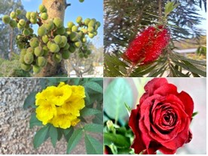
Floral species are divided into 9 parts:
Trees
Herbs
Shrubs
Succulents
Climbers
Fruit Trees
Grass
Weeds
Flowering plants

Whereas the Faunal species is divided into 11 classes:
Mammalia
Aves
Reptilia
Arachnida
Insecta
Pisces
Amphibia
Gastropoda
Clitellata
Turbellaria
Malacostraca

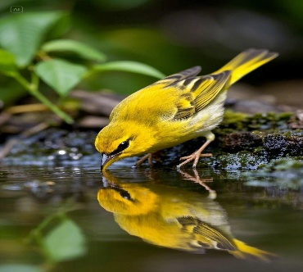

- Mapping and locating the quadrats and belt transect through GPS imagery system:
In monitoring the biodiversity and the key species present in each of the quadrats and transect lines, I utilized Google Earth to locate the quadrats and transects throughout the site, using a combination of the site map and satellite imagery and overwriting it with a Google Earth bird's eye perspective. I found representative habitats within each of the Key Biodiversity Zones and characterized a precise point for each of the quadrats and then aligned straight transects that went across areas of interest. This aligned strategy supported a systematic approach and make it easier to revisit and collect data on those specific locations. Google Earth was a crucial tool in enabling spatial planning and logic, enhancing the overall rigour of this survey by facilitating a clear visual reference of the layout of the sampling points across the whole of the campus.

20m
100m

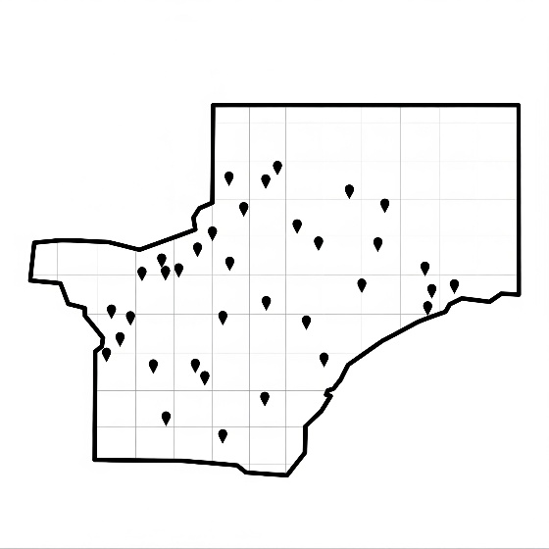


(B)

Fig 9: This picture is only for demonstration purpose
where fig (A) is showing the belt transect method used
for the faunal data collection & fig (B) is showing the mapping of quadrats for floral data collection.

- Data processing: The data processing and preparation phase was essential for ensuring the accuracy, consistency, and usability of the excel dashboard for Ashok Leyland. This phase involved meticulous steps to consolidate, clean, and structure the data, enabling effective analysis and reporting through the dashboard.
- Data aggregation and consolidation: Upon completing the data collection for the quadrats and transects, I set out to consolidate all flora and fauna observations into a single database structure. This required me to compile the abundance/number of species, habitat type, and GPS locations for species in the identified Key Biodiversity Zones of each plant. Zooming from Unit 1 and Unit 2 data, I was then able to compare the richness, abundance, and distribution of species with the quadrats and transects at KCSNP. Following this solid foundation of site-wide observance, I was able to assess the ecological status of habitats by identifying hot spots of biodiversity that could be identified for particular management into the future. Completing the consolidation meant I could also perform site specific data aggregation for both plants from a meaningful set metrics and trends. This involved filtering the data on a zone by zoned basis, which allowed me to discern areas that exhibited unique or rare species, reflect on the relative quality of habitat, and examine the trends and patterns likely induced by species diversity and species interactions - ecological interactions. This logic gave me the suitable site specificity in the recommendations for conservation and restoration recommendations, while ensuring that the data had been ordered in not only an organised way but also suitable so that I could encompass simple insights into sustainable management of biodiversity from the current situation.

- Maintaining Data Consistency and Accuracy: To ensure the dependability of the biota data taken across both units, data were carefully cross-checked, which involved distributing the observations and zone mapped data to internal stakeholders, such as site engineers, environmental officers, and horticultural staff.
They provided additional context and feedback on the data that could help identify and resolve discrepancies or errors in terms of species counts, zone classifications, or GPS coordinates. Ultimately, this process put final dataset through a step of review that built a level of accuracy and actually represented the biodiversity status of the campus.

- Data Cleaning:
Extensive Validation and Refinement: Data cleaning for the biodiversity dataset at Ashok Leyland took a while, but it focused on eliminating inconsistencies, addressing missing data and reviewing and mitigating unusual observations. Where counts of missing species or GPS points were lost in the process, we visited the sites again and probed knowledgeable resources and checked unusual data points that we thought needed attention and re-enrolled in the database in such a way, we think movements and records remained intact. To allow comparability across both Hosur units, we undertook to standardise naming conventions, units of measure and formats of data. For example, we aligned species names to recognised botany naming conventions and converted spatial and quantities to remove a comparison between metrics measuring the same thing across the two facilities.

- Data Structuring: Organized Framework for Analysis.
After data refinement, the data was put into a comprehensive, hierarchical structure suitable for rigorous analysis and pivoting. The data was separated into various biodiversity classifications which included Flora, Fauna, Habitat Areas and Conservation Areas. Within each classification, there were further subdivisions; flora was organized by species, life form and conservation status, and fauna was organized by class, behaviour and frequency of observations. This enabled simple filtering, comparative analysis and dynamic pivoting in Excel or GIS.
With the inclusion of the above structural additions, the biodiversity data for Ashok Leyland evolved into a more significant and useable asset. This resulted in better monitoring, improved trend analysis and greater informed decision-making for biodiversity conservation and habitat management for both Hosur units.

Results

The design and development of the Biodiversity Dashboard for Ashok Leyland focused on creating an accessible, user-friendly interface combined with robust analytical capabilities. The goal was to enable stakeholders across departments to easily interpret complex ecological data, making it actionable for conservation planning and site management. Each and every result along with its calculation is mentioned below that caters for the work done in the internship so far.

USER INTERFACE:
- The dashboard has a clear, intuitive layout that allows staff at all levels to quickly navigate to information. The layout allows staff to locate the biodiversity information quickly, particularly the information that pertains to species counts, conservation status, and trends over time. As a result, the dashboard is a useful tool for technical teams and for decision-makers.
- Visual Aids:
To help provide clarity in the data presentation, it was necessary to use visual aids such as bar graphs, line graphs, and category-based pie charts. Bar graphs were used to show the changes in forest cover over the previous five years in Unit 2, while line graphs were used to display species richness and abundance over time. Pie and bar charts were useful ways to show the distribution of species across IUCN Red List categories and the various schedules of the Wildlife Protection Act (1972), giving an easily digestible overview of some of the vital measures of conservation outcomes.
- Interactive Elements:
Interactive features like drop-down menus, slicers, and category filters were incorporated to enable dynamic exploration of the dataset. Users can filter the data based on classification i.e., selecting a specific plant category (herbs, shrubs or trees), fauna class (one of the eleven classes) or a particular conservation status. These elements ensure that stakeholders can quickly locate and compare relevant information based on their role and focus area.
- Pivot Tables:
Pivot tables were built into the dashboard to allow the user to conduct more robust and flexible analysis of species data in time and space. These pivot tables allow them to summarize large datasets quickly, compare species richness across years, and to examine composition of habitats. This allows the user to make changes and drill down into specific species counts or on certain conservation statuses, giving the user a more complex view of their data and trends that will allow the user to work towards data‑driven conservation planning or habitat restoration.

- Charts/Graphs used:
- Funnel chart
- Line charts
- 3D Bar charts
- Doughnut charts
- Area charts
- 2D Bar charts
- Spider web charts
- Hierarchy chart
- Waterfall chart
- Accessibility:
- The biodiversity dashboard was built in Microsoft Excel, a tool familiar to Ashok Leyland staff, ensuring easy accessibility and user-friendliness.
- The simple structure and intuitive design made it a simple matter to access specific information and explore the data.
- Such a design meant that special training, or manuals for use, were not necessary for team members to use it.

Fig 10: Faunal classified data

Fig 11: Floral classified data
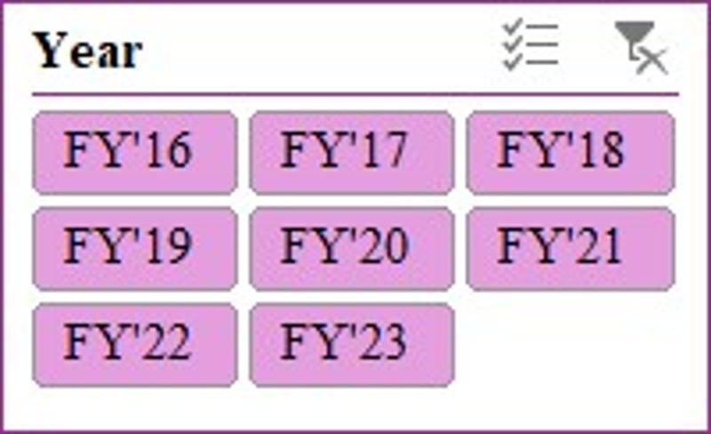

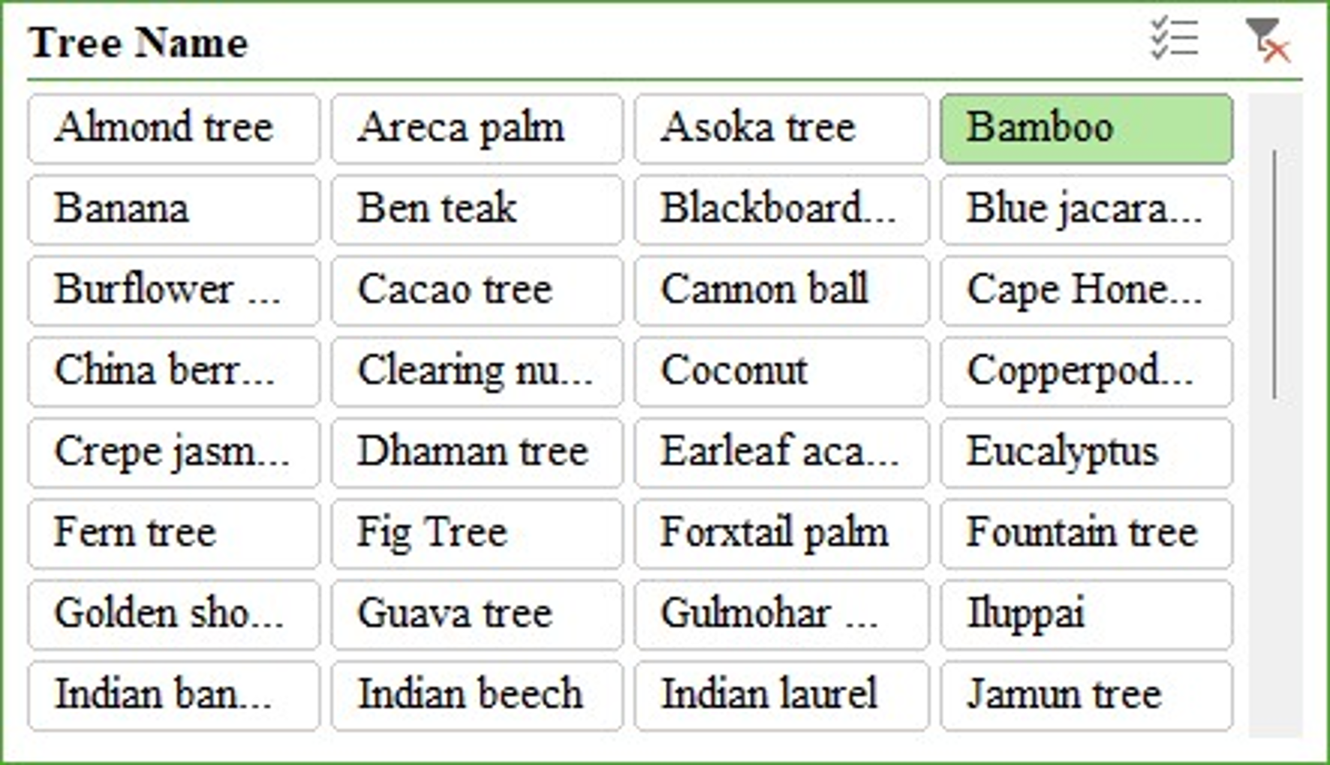

Fig 12: Trend of trees after afforestation programme (2016-2013)

- Phytosociological analysis:
Total number of tree individuals’ data was recorded on the site in every quadrat. Whereas shrubs, climbers, flowers, grass, succulents and herbs were similarly recorded to get the idea of their Abundancy, frequency, richness, and evenness. Various formulas were used to get the outcomes. Every species frequency and abundance outcomes are indicated in the table below with calculated values. Species richness is formulated with Shannon-wiener index and shown in the table below to get the idea of the diversity and richness of floral species. This mathematical calculation will give us the idea of homogeneity and heterogeneity of species, frequently occurring species, most and least abundant species inside the proposed area of AL. After covering all the sites, we get the insights as an output.

- Percentage frequency calculation:
The frequency of individual species is the number of times the species occur in the sampling unit or the degree of dispersal of species. The purpose of frequency analysis is to find the presence and distribution of the species within the premises. It is usually represented as a percentage calculated as below.

- Relative Abundance:
Relative abundance of the species indicates the total number of individuals of a particular species with respect to the total number of species of all individuals within an area or any specific community Where this study refers to the premise of Ashok Leyland Hosur manufacturing units.

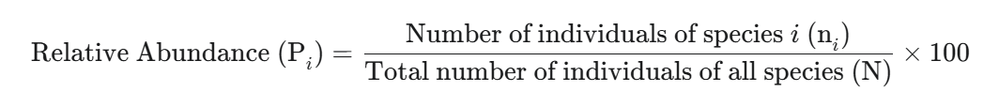

- Density Calculation:
In ecology, species density refers to the number of individuals of a particular species per unit area or volume. It's a measure of how crowded a species is within a given space.
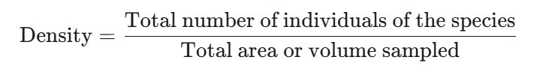

- Species Richness (Shannon and wiener Index):
The Shannon-Wiener Index, often referred to as the Shannon Index, is a commonly used diversity index in ecology that measures species diversity in a community. The Shannon-Wiener Index accommodates species richness (the number of species) and relative abundance (how evenly distributed they are). The greater the value of the Shannon-Wiener Index, the more diverse (i.e., species rich and evenly distributed) will be the community. The lower the Shannon-Wiener Index, the more limited the diversity (due to few number of species or even dominance of one or few species). The Shannon-Wiener Index is particularly useful for gauging the diversity of different communities or tracking the temporal changes in diversity (using the same community) over time.
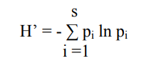

Where:
- H′ = The Shannon Wiener Diversity Index
- S = The total number of species in the community (species richness)
- p_{i}​ = The proportion of individuals belonging to the i^{th} species (i.e., the number of individuals of species i divided by the total number of individuals of all species)
- ln = The natural logarithm
Calculation:
STEP-1
Tress Species (U-2) | Frequency (U-2) | Tress Species (U-1) | Frequency (U-1)
Alstonia Scholaris | 11.68 | Alstonia Scholaris | 1.71
Alstonia Macrophylla | 5.32 | Alstonia Macrophylla | 1.78
Bauhinia Racemosa | 14.84 | Bauhinia Racemosa | 4.36
Aegle marmelos | 2.16 | Terminalia Arjuna | 1.79
Terminalia Arjuna | 2.26 | Azadirachta Indica | 20.36
Cassia Javanica | 7.89 | Murraya Koenigii | 6.07
Azadirachta Indica | 1.05 | Ficus benghalensis | 7.4
Murraya Koenigii | 7.47 | Thespasia populnea | 4.36
Ficus benghalensis | 7.47 | Dalbergia Sissoo | 1.79
Nyctanthes Arbor tristes | 8.16 | Mangifera indica | 20
Table 1: Depicting species frequency
Note: Data represented here has no similarity with the actual one. It is for representation purpose.
STEP-2
Tress Species (U-2) | Relative abundancy | Tress Species (U-1) | Relative abundancy
Alstonia Scholaris | 1.18 | Alstonia Scholaris | 1.00
Alstonia Macrophylla | 0.01 | Alstonia Macrophylla | 0.21
Bauhinia Racemosa | 0.088 | Bauhinia Racemosa | 0.59
Aegle marmelos | 0.43 | Terminalia Arjuna | 0.74
Terminalia Arjuna | 0.29 | Azadirachta Indica | 1.73
Cassia Javanica | 0.31 | Murraya Koenigii | 0.89
Azadirachta Indica | 1.18 | Ficus benghalensis | 0.29
Murraya Koenigii | 0.29 | Thespasia populnea | 0.49
Ficus benghalensis | 0.58 | Dalbergia Sissoo | 0.10
Nyctanthes Arbor tristes | 0.29 | Mangifera indica | 0.33
Table 2: Depicting species Relative abundancy
STEP-3
∑ Individual (02) | ∑ Individual (01)
102 | 20
40 | 40
75 | 16
12 | 17
32 | 39
72 | 29
11 | 80
36 | 12
33 | 20
90 | 24

Table 3: Depicting sum of individual species
STEP-4
Pi (U-2) | Log (Pi) | Pi*Log (Pi)
0.0151753 | -4.188 | -0.0635557
0.0060128 | -5.113 | -0.0307489
0.0108804 | -4.520 | -0.0491882
0.0014316 | -6.548 | -0.0093757
0.0042949 | -5.450 | -0.0234086
0.011309 | -4.482 | -0.0506920
0.0161775 | -4.124 | -0.0667182
0.0042949 | -5.450 | -0.0234086
0.0045812 | -5.385 | -0.024673
0.0012884 | -6.65 | -0.0085738
Pi (U-1) | Log (Pi) | Pi*Log (Pi)
0.0108 | -4.52 | -0.049074
0.0019 | -6.22 | -0.012285
0.0069 | -4.97 | -0.034349
0.0064 | -5.04 | -0.032370
0.0172 | -4.05 | -0.070059
0.0098 | -4.61 | -0.045552
0.0039 | -5.53 | -0.02183
0.004 | -5.31 | -0.02619
0.0009 | -6.92 | -0.006826
0.0133 | -4.3 | -0.05750
Table 4: Depicting Log of proportion of individuals
STEP-5
Total count of species in both the plant
Unit -1 Unit -2
8223 4958

STEP-6
∑Pi*Ln(Pi)

Unit -1 Unit -2
-2.655667 -2.187229

STEP-7
Calculation of Shannon-Weiner Index, which will be calculated as.
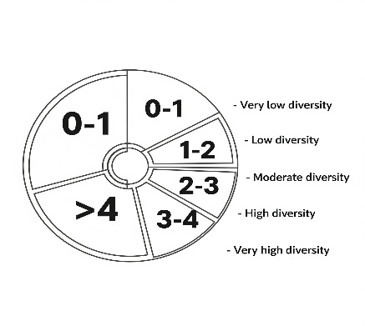
-1* ∑Pi*Ln (Pi) or multiplying by -1 so that the natural log value comes to positive.
After calculating through this way, we got the species richness of flora but due to inadequacy in the data of fauna, we have not calculated it. This data gives us the idea of mixture of species or richness on the site. It also indicates a healthy ecological condition with reasonable habitat complexity.

- TNFD LEAP Approach: Any organisation has dependency and impacts on nature which gives rise to nature related risk and opportunities. These four concepts are collectively referred by the TNFD as ‘nature-related issues’ and include (TNFD. 2023.Guidance on the identification and assessment of nature-related issues: The LEAP approach.). From the outset of the TNFD’s work, market participants indicated that accessible guidance outlining how to identify, assess, manage and disclose nature related issues would be a welcome complement to the TNFD’s recommended disclosures. In response, the TNFD has worked with knowledge partners and providers of relevant existing frameworks to develop an integrated approach for the assessment of nature related issues. It is designed for use by organisations of all sizes and across all sectors and geographies. This integrated assessment approach is called the LEAP approach, or ‘LEAP’ for short (Locate, Evaluate, Assess and Prepare)

• Locate your interface with nature.
• Evaluate your dependencies and impacts on nature
• Assess your nature-related risks and opportunities
• Prepare to respond to, and report on, material nature-related issues, aligned with the TNFD’s recommended disclosures

Wherever possible, the TNFD has avoided creating new or different approaches. It has instead drawn on existing high-quality assessment methodologies and tools that are already used by market participants. By design, LEAP builds on, and is consistent with, existing assessment frameworks including the Natural Capital Protocol developed by the Capitals Coalition and the target setting methods developed by the Science Based Targets Network (SBTN). It is also consistent with the materiality assessment approach used by the International Sustainability Standards Board (ISSB) and the impact materiality assessment approaches used by the GRI and in the European Sustainability Reporting Standards (ESRS). It signposts to well-regarded scientific data sets and assessment tools including those provided by the International Union for Conservation of Nature (IUCN), Stockholm Resilience Centre, UN Statistics Division, UN Environment Programme World Conservation Monitoring Centre (UNEP-WCMC), WWF and others. (Ref to TNFD guidelines. 2023).
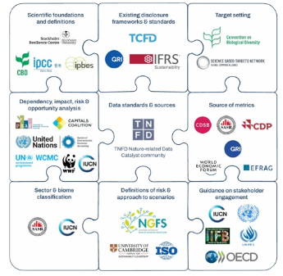

Fig 13: TNFD
Guidelines build
On existing
Framework.

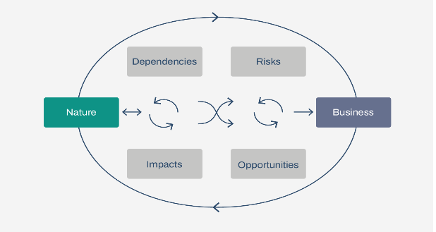

Fig 14: Nature-related dependencies, impacts, risks and opportunities

- Dependencies: Dependencies are aspects of environmental assets and ecosystem services that a person or an organisation relies on to function. A company’s business model, for example, may depend on the ecosystem services of water flow, water quality regulation and the regulation of hazards like fires and floods; provision of suitable habitat for pollinators, who in turn provide a service directly to economies; and carbon sequestration.
- Impacts: Impacts refer to a change in the state of nature (quality or quantity), which may result in changes to the capacity of nature to provide social and economic functions. Impacts can be positive or negative. They can be the result of an organisations or another party’s actions. Impacts may be:
• Direct - a change in the state of nature caused by a business activity with a direct causal link.
• Indirect - a change in the state of nature caused by a business activity with an indirect causal link (e.g. indirectly caused by climate change generated by greenhouse gas emissions).
• Cumulative - a change in the state of nature (direct or indirect) that occurs due to the interaction of activities of different actors operating in a landscape or freshwater/marine area.
- Risk - Potential threats posed to an organisation linked to its and other organisations impacts on biodiversity and dependencies on ecosystems. These can derive from physical, transition and systemic risks.
- Opportunity - Nature-related opportunities are positive outcomes for organizations that arise from actions to mitigate nature-related risks, reduce impacts, or build resilience. These may include:
- Access to new markets or revenue streams (e.g., sustainable products).
- Improved resource efficiency (e.g., water and energy use).
- Enhanced brand value and stakeholder trust through positive environmental performance.

- Locating KBAs with IBAT (A tool for key global biodiversity datasets):
The Integrated Biodiversity Assessment Tool (IBAT) provides fast, easy and integrated access to critical biodiversity information. IBAT can be used to screen for areas of biodiversity importance using the World Database of Protected Area, the World Database on Key Biodiversity Areas and the IUCN Red List of Threatened Species.
The IBAT biodiversity map offers a rapid visual screening for critical global biodiversity areas. Users can explore the interactive map by adding several layers to identify Key Biodiversity Areas, protected areas, and areas important for threatened species. These datasets are recommended by the TNFD for assessing biodiversity importance in L4 of the LEAP approach. Biodiversity importance is one of the five TNFD criteria for sensitive locations.
- How does IBAT support the TNFD guidance and recommendations?
IBAT can help organisations to identify sensitive locations in component L4 of the ‘Locate’ phase of the LEAP Approach. The datasets within IBAT are recommended by the TNFD as they offer a scientifically robust starting point for assessing the sensitivity of locations based on biodiversity importance.
The identification of sensitive locations is also important for TNFD recommended disclosure Strategy D.
The map is underpinned by three global biodiversity datasets providing integrated access to:
- The World Database on Protected Areas
- The World Database of Key Biodiversity Areas
- The IUCN Red List of Threatened Species in addition to the Species Threat Abatement and Restoration (STAR) metric and Rarity Weighted Richness layer- both derived data layers from the IUCN Red List of Threatened Species.
- Where do the data layers source from?
This map is powered by the Integrated Biodiversity Assessment Tool (IBAT). IBAT is underpinned by three global biodiversity datasets providing integrated access to the World Database on Protected Areas, the World Database of Key Biodiversity Areas, and the IUCN Red List of Threatened Species in addition to the Species Threat Abatement and Restoration (STAR) metric and Rarity Weighted Richness layer -both derived data layers from the IUCN Red List of Threatened Species.
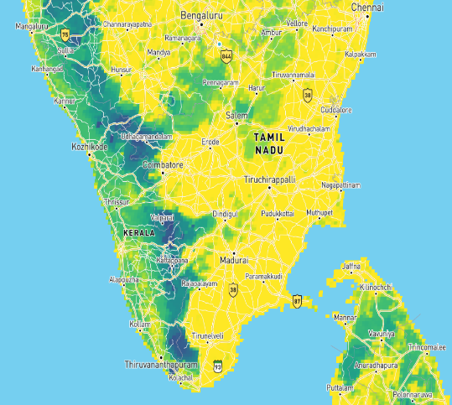
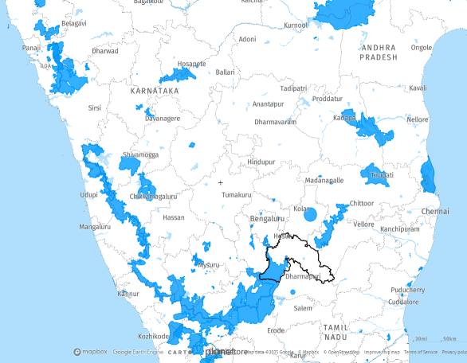
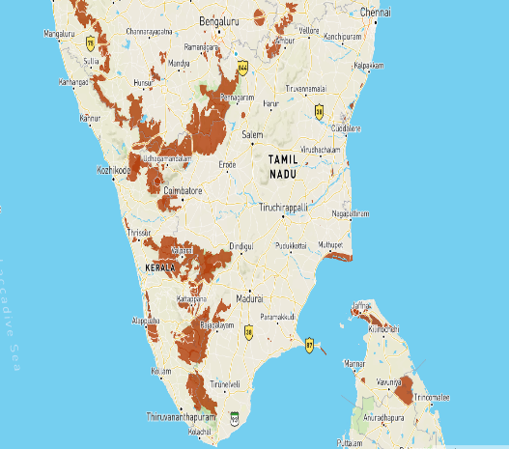

Fig 15: IBAT located KBAs, protected areas and STAR 5 Km. resolution near to AL Hosur plants.
- Governance: For any smooth operation and working of a company, there is a need of a good governance structure. At Ashok Leyland, we developed a governance structure with the existing one with sustainability that will play a pivotal role in the biodiversity conservation and risk mitigation at the site and prevent any kind of threat to the environment that can be a reputational risk for AL too in near future.

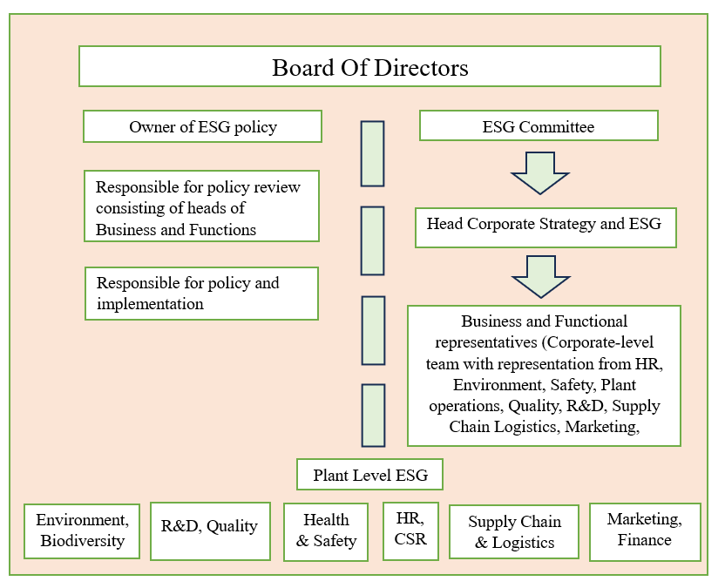

Fig 16: Representing the governance of AL for Biodiversity and environment

- WWF risk filter (Locating dependency and impact)
We also have used WWF’s Biodiversity and water risk filter to assess and analyse the relevant biodiversity and ecosystem risks to AL’s operation in Hosur.
Aim:
1. Analyse the biodiversity and water related risk with the regional data available.
2. To provide insights from the risk filter and create strategy for the future, aligned with the biodiversity policy of Ashok Leyland.

Scope:
- Own operations spreading in Hosur.

- Surrounding area of the manufacturing properties.

- Water risk level

Basin Physical Risk | BPH | 3.72 | Operational Physical Risk | OPH | 2.66
1. Water Availability | BRC1 | 3.2 | 1. Water Scarcity | ORC1 | 2.6
2. Drought | BRC2 | 4.5 | 3. Water Quality | ORC3 | 2.75
3. Flooding | BRC3 | 3.5 | Operational Regulatory Risk | ORG | 1.8
4. Water Quality | BRC4 | 3.72 | 5. Enabling Environment | ORC5 | 2
5. Ecosystem Services Status | BRC5 | 3.5 | 6. Institutions & Governance | ORC6 | 1.6
Basin Regulatory Risk | BRG | 3.3 | Operational Reputational Risk | ORP | 2.89
6. Enabling Environment | BRC6 | 3.5 | 11. Media Scrutiny | ORC11 | 1
7. Institutions & Governance | BRC7 | 3.5 | 12. Conflict | ORC12 | 3.9
8. Management Instruments | BRC8 | 3 | 1. Water Scarcity | O1 | 2
9. WASH Infrastructure | BRC9 | 3 |  | O2 | 5
Basin Reputational Risk | BRP | 2.92 |  | O3 | 3
10. Environmental Factors | BRC10 | 2.5 |  | O4 | 3
11. Socioeconomic Factors | BRC11 | 3.8 |  | O4a | 0
12. Additional Reputational Factors | BRC12 | 2.6 |  | O4b | 0
1. Water Availability | B1_1 | 4 |  | O4c | 0
 | B1_2 | 5 |  | O4d | 0
 | B1_3 | 5 |  | O4e | 0
 | B1_4 | 1 |  | O4f | 0
2. Drought | B2_1 | 5 |  | O4g | 0
 | B2_2 | 4 |  | O5 | 1
3. Flooding | B3_1 | 4 |  | O5a | 0
 | B3_2 | 3 |  | O5b | 0
4. Water Quality | B4_1 | 4 |  | O5c | 0
 | B4_2 | 2 |  | O5d | 0
 | B4_3 | 2 |  | O5e | 0
 | B4_4 | 5 |  | O5f | 0
 | B4_5 | 5 |  | O5g | 0
 | B4_6 | 3 |  | O6 | 1
 | B4_7 | 4 | 3. Water Quality | O7 | 1
 | B4_8 | 5 |  | O7a | 0
 | B4_9 | 4 |  | O7b | 0
5. Ecosystem Services Status | B5_1 | 1 |  | O8 | 3
 | B5_2 | 5 |  | O9 | 5
 | B5_3 | 4 |  | O10 | 2
 | B5_4 | 3 |  | O11 | 1
 | B5_5 | 3 | 5. Enabling Environment | O12 | 2
 | B5_6 | 4 |  | O13 | 2
6. Enabling Environment | B6_1 | 3 | 6. Institutions & Governance | O14 | 1
 | B6_2 | 4 |  | O15 | 1
7. Institutions & Governance | B7_1 | 3 |  | O15a
 | B7_2 | 4 |  | O16 | 3
8. Management Instruments | B8_1 | 3 | 11. Media Scrutiny | O17 | 1
 | B8_2 | 3 |  | O18 | 1
9. WASH Infrastructure | B9_1 | 2 | 12. Conflict | O19 | 5
 | B9_2 | 4 |  | O20 | 5
10. Environmental Factors | B10_1 | 2 |  | O21 | 1
 | B10_2 | 5 |  | O22 | 3
 | B10_3 | 1
 | B10_4 | 2.5
 | B10_5 | 2
11. Socioeconomic Factors | B11_1 | 5
 | B11_2 | 4
 | B11_3 | 2
12. Additional Reputational Factors | B12_1 | 5 |  | 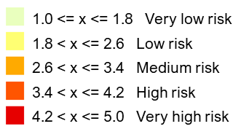
 | B12_2 | 1
 | B12_3 | 1
Table 5: Depicting water risk filter by WWF
This above is showing WWF’s Water risk filter data which provides the detailed assessment of water related risks segmented across Basin level (refers to the nature and condition of the broader river basins where a company operates & are external to the facility itself) and operational level (refers to the direct or indirect water related issues posed to a company’s day to day operations within its immediate operational area) in physical, regulatory and reputational aspects. The basin physical risk has a high composite score of 3.72, which indicates the greater exposure to physical threats like droughts, floods or water quality issues in the basin. Similarly, basin regulatory risk of 3.3 shows the moderate regulatory framework or institutional capacity which may further increase the operational risk. Notably, the basin reputational risk of 2.92 indicates the high potential of water conflicts, stakeholder concern and other socioeconomic factors.
On the operational risk front, the (OPH) is 2.66 which is in the lower to moderate risk zone category indicating the moderate exposure of the facility to water quality and water scarcity. Whereas the operational regulatory score of 1.8 falls in the very low risk zone depicting that there is stable regulations and less legal constraints related to water. On the other hand (ORP) operational reputational risk score of 2.89 depicts that there are likely chances of local conflict, social pressure and media at the operational site.
Whereas O4a and O4b under water scarcity denotes- the specific total annual amount of water withdrawn (directly from any water source including municipal supply utilities) in m³/year and the specific total annual amount of water withdrawn from fresh surface water (e.g., river, lake, rainwater) in m3/year?
O5 depicts the total annual amount of water discharged from this site to any endpoint (including municipal wastewater utilities) in m³/year which is very low and shows the mindful discharge of water. Overall, after analysing, we can say the water risk according to WWF is in moderate zone and the site is accountable & has strategically planned to mitigate any risks arising from the site further.

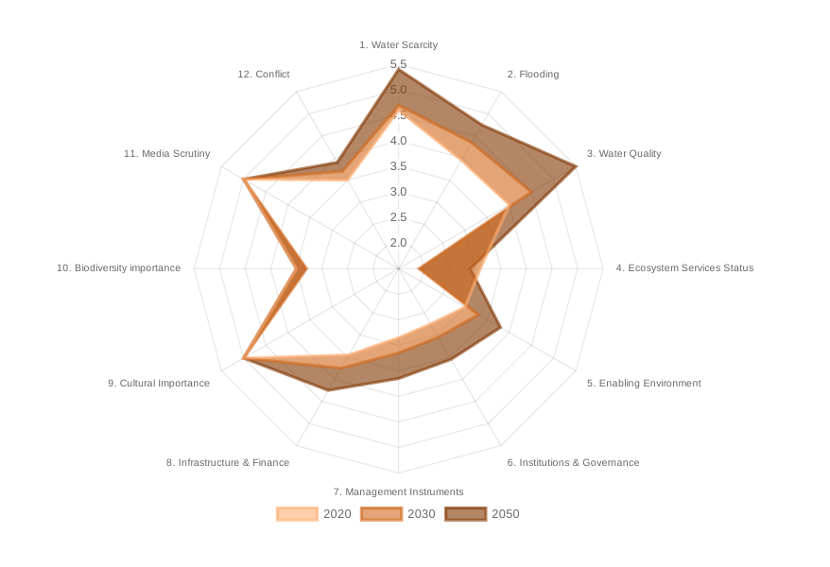
Fig 17 – Refers to the WWF water risk filter. Showing various risk categories across time.

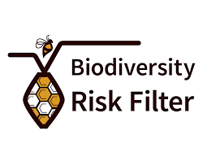
- Biodiversity risk level

Fig 18 – Refers to WWF biodiversity risk filter scape scores

The scape physical score of ALH1 & ALH2 is moderate and shows a value of 3.00, which suggests that the plant is exposed to notable environmental pressures. Including water scarcity, ecosystem degradation and other challenges that may impact the continuity of operation and resource availability. Whereas the scape reputational risk score of 2.81 depicts a moderate sensitivity to public perception and stakeholder scrutiny. Perhaps, driven by environmental, social and governance related subjects.

Scape Physical Risk | SPH | 3 | Scape Physical Risk | SPH | 3
1. Provisioning Services | SRC1 | 3.8 | 1. Provisioning Services | SRC1 | 4.2
1.1 Water Availability | S1_1 | 3.6 | 1.1 Water Availability | S1_1 | 4.4
1.2 Forest Productivity and Distance to Markets | S1_2 | No dependency or impact | 1.2 Forest Productivity and Distance to Markets | S1_2 | No dependency or impact
1.3 Limited Wild Flora & Fauna Availability | S1_3 | 4 | 1.3 Limited Wild Flora & Fauna Availability | S1_3 | 4
1.4 Limited Marine Fish Availability | S1_4 | NA | 1.4 Limited Marine Fish Availability | S1_4 | NA
2. Regulating & Supporting Services - Enabling | SRC2 | 2.75 | 2. Regulating & Supporting Services - Enabling | SRC2 | 2.25
2.1 Soil Condition | S2_1 | No dependency or impact | 2.1 Soil Condition | S2_1 | No dependency or impact
2.2 Water Condition | S2_2 | 2.75 | 2.2 Water Condition | S2_2 | 2.25
2.3 Air Condition | S2_3 | 3.5 | 2.3 Air Condition | S2_3 | 3.5
2.4 Ecosystem Condition | S2_4 | No dependency or impact | 2.4 Ecosystem Condition | S2_4 | No dependency or impact
2.5 Pollination | S2_5 | No dependency or impact | 2.5 Pollination | S2_5 | No dependency or impact
3. Regulating Services - Mitigating | SRC3 | 3 | 3. Regulating Services - Mitigating | SRC3 | 3
3.1 Landslides | S3_1 | 2.5 | 3.1 Landslides | S3_1 | 2.5
3.2 Wildfire Hazard | S3_2 | 3 | 3.2 Wildfire Hazard | S3_2 | 3
3.3 Plant/Forest/Aquatic Pests and Diseases | S3_3 | No dependency or impact | 3.3 Plant/Forest/Aquatic Pests and Diseases | S3_3 | No dependency or impact
3.4 Herbicide Resistance | S3_4 | No dependency or impact | 3.4 Herbicide Resistance | S3_4 | No dependency or impact
3.5 Extreme Heat | S3_5 | 3.5 | 3.5 Extreme Heat | S3_5 | 3
3.6 Tropical Cyclones | S3_6 | 3 | 3.6 Tropical Cyclones | S3_6 | 3
4. Cultural Services | SRC4 | No dependency or impact | 4. Cultural Services | SRC4 | No dependency or impact
4.1 Natural & Cultural Resources | S4_1 | No dependency or impact | 4.1 Natural & Cultural Resources | S4_1 | No dependency or impact
5. Pressures on Biodiversity | SRC5 | 3 | 5. Pressures on Biodiversity | SRC5 | 3
5.1 Land, Freshwater and Sea Use Change | S5_1 | 2.5 | 5.1 Land, Freshwater and Sea Use Change | S5_1 | 2.5
5.2 Forest Canopy Loss | S5_2 | 1 | 5.2 Forest Canopy Loss | S5_2 | 1
5.3 Invasives | S5_3 | No dependency or impact | 5.3 Invasives | S5_3 | No dependency or impact
5.4 Pollution | S5_4 | 4.5 | 5.4 Pollution | S5_4 | 4.5
Scape Reputational Risk | SRP | 2.81 | Scape Reputational Risk | SRP | 2.81
6. Environmental Factors | SRC6 | 2 | 6. Environmental Factors | SRC6 | 2.12
6.1 Protected/Conserved Areas | S6_1 | 2 | 6.1 Protected/Conserved Areas | S6_1 | 2
6.2 Key Biodiversity Areas | S6_2 | 2 | 6.2 Key Biodiversity Areas | S6_2 | 2.5
6.3 Other Important Delineated Areas | S6_3 | 1.5 | 6.3 Other Important Delineated Areas | S6_3 | 1.5
6.4 Ecosystem Condition | S6_4 | 2.12 | 6.4 Ecosystem Condition | S6_4 | 2.12
6.5 Range Rarity | S6_5 | 2 | 6.5 Range Rarity | S6_5 | 2
7. Socioeconomic Factors | SRC7 | 3 | 7. Socioeconomic Factors | SRC7 | 3
7.1 Indigenous Peoples (IPs); Local Communities (LCs) Lands and Territories | S7_1 | 3 | 7.1 Indigenous Peoples (IPs); Local Communities (LCs) Lands and Territories | S7_1 | 3
7.2 Resource Scarcity: Food - Water - Air | S7_2 | 2.5 | 7.2 Resource Scarcity: Food - Water - Air | S7_2 | 2.9
7.3 Labor/Human Rights | S7_3 | 3 | 7.3 Labor/Human Rights | S7_3 | 3
7.4 Financial Inequality | S7_4 | 2 | 7.4 Financial Inequality | S7_4 | 2
8. Additional Reputational Factors | SRC8 | 2.62 | 8. Additional Reputational Factors | SRC8 | 2.62
8.1 Media Scrutiny | S8_1 | 3 | 8.1 Media Scrutiny | S8_1 | 3
8.2 Political Situation | S8_2 | 2.5 | 8.2 Political Situation | S8_2 | 2.5
8.3 Sites of International Interest | S8_3 | 1.5 | 8.3 Sites of International Interest | S8_3 | 1.5
8.4 Risk Preparation | S8_4 | 1.5 | 8.4 Risk Preparation | S8_4 | 1.5
Table 6: Refer to WWF biodiversity risk filter
Metrics in the left-hand side is showing the biodiversity risk results of AL unit Ⅱ whereas the metrics in right hand side is showing risk results for biodiversity of AL unit I simultaneously. The output with the impact and dependency for the same are as follows:
- Provisioning Services (SRC1): 3.8-4.2 shows a high & increasing dependency and risk related to natural resources.
- Regulating & Supporting Services – Enabling (SRC2): 2.75-2.25 It shows the increased resilience and decreased ecosystem service support including lesser dependency.
- Regulating Services – Mitigating (SRC3): 3 depicting moderate risk level due to wildfire Hazard, Tropical Cyclones, extreme heat and others.
- Cultural Services (SRC4): No dependency or impact
- Pressures on Biodiversity (SRC5): 3 indicates moderate direct pressures on biodiversity.
- Environment factors (SRC6): 2-2.12 shows a very minimal level of concern to ecological zones or any key biodiversity zones nearby.
This high-level preliminary assessment was supposed to be helpful to drive the adoption and implementation of risk filter and LEAP approach for identification of nature related risk and opportunities.

- Habitat Integrity calculation: Habitat integrity is defined as the health, stability and functionality of a natural habitat, and the ability of that habitat to sustain native species and the natural processes essential for their population persistence over time. Habitat integrity incorporates ecosystem quality, structure, and connectivity, and implies a state of the physical environment, species composition, and biological interactions reflective of resilience, such that the native flora and fauna is diverse and requires little or no human management, and function is limited only by natural dynamics, including nutrient cycling, predator-prey relationships, and processes associated with regeneration.
Evaluating habitat integrity is important for conservation of biodiversity, because degraded or fragmented habitats lead to species richness that is limited due to competition from non-native species and related stress from the absence of functioning ecological dynamics. Environmental factors that degrade, fragment, or replace ecosystems include pollution, habitat loss, deforestation and development of infrastructure. In aggregate all of these factors reduce the effectiveness of ecosystems to adapt to stress and persist with biodiversity. Monitoring or advocating for habitat integrity are baseline activities that provide some assurance toward the sustainability of ecosystems services and the persistence of ecological resilience long-term.

A particular heatmap was made to show the Habitat integrity:

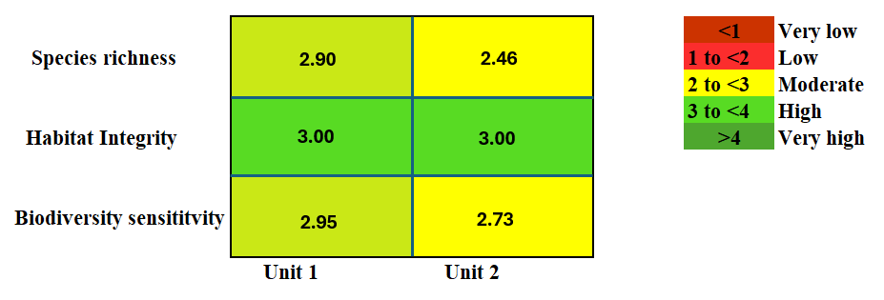

Fig 19: Showing habitat integrity & biodiversity sensitivity through heat map
Calculation:
0-1 | Very low
1 to 2 | low
2 to 3 | moderate
3 to 4 | high
>4 | very high
Plant Location | Noise dbs (Avg) | Water PH level (Avg) | Soil PH Level (Avg)
H1 | 53.2 | 7.22 | 6.34
H2 | 56.88 | 7.06 | 6.5

- Benchmark for Noise
The Tamil Nadu Pollution Control Board (TNPCB) noise standard for a commercial area during daytime is 75 dbs. Therefore:
- If noise is below or equal to 75 dB, it’s considered safe.
- If noise exceeds 75 dB, it’s considered poor.
Our Average Noise value in dbs (measured through sound measuring equipment) – Near all the heavy manufacturing area near to the biodiversity zone delineated inside the plant to ensure no problem to biodiversity by noise pollution.
- 53.2 dB
- 56.88 dB
Both are below the 75 dB threshold, which is good.
- Benchmarks for Water and Soil pH – Water and soil PH were measured through Litmus paper by us at various locations to get the idea of the soil condition and waterbodies condition, so that we can identify there is no discharge into waterbodies or at any piece of land and through it there is no threat to biodiversity in surrounding including ecosystem services.
The standard pH range for:
- Water (for drinking & irrigation): 6-8 (BIS standard for drinking water: ISO 10500:2012).
- Soil (ideal for most crops & soil health, FAO): 6.0-7.5.

- Deviation Calculation
We’ll measure deviation from the ideal midpoint of these ranges to assess the risk.
- Water pH range midpoint: (6+ 8)/2 = 7
- Soil pH range midpoint: (6 + 8)/2 = 7

- Calculate Deviation for Each Parameter
- Noise benchmark: 75 dB
- Deviation for noise = (Benchmark - Observed)/Benchmark
    - For 53.2 dB:|75 - 53.2| /75 = 0.29
    - For 56.88 dB:|75 - 56.88| /75 = 0.24
For Water pH:
- Deviation for water pH = |Observed - Midpoint| / Midpoint
    - For 7.22: |7.22 - 7| / 7 = 0.0314
    - For 7.06: |7.06 - 7| / 7 = 0.0086
For Soil pH:
- Deviation for soil pH = |Observed - Midpoint| / Midpoint
  - For 6.5: |6.34 - 7| / 7 = 0.0714
  - For 6.34: |6.5 - 7| / 7 = 0.0943

- Total Deviation value
For each sample:

Sample 1:
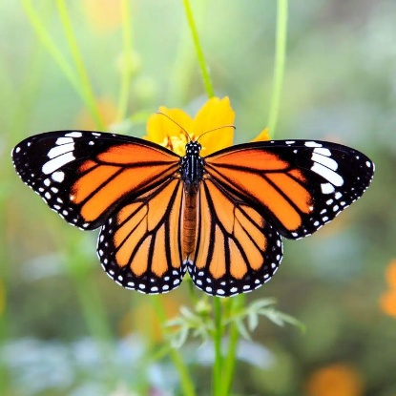
- Noise: 0.29
- Water: 0.0314
- Soil: 0.0714
- Total deviation: 0.29+0.0314+0.0714= 0.3928
Sample 2:
- Noise: 0.24
- Water: 0.0086 Fig 20: Monarch butterfly
- Soil: 0.0943
- Total deviation: 0.24 + 0.0086+0.0943=0.3429
Standard deviation is a measure of how much individual values deviate from the mean (average). In environmental or biodiversity assessments:
- Smaller standard deviation shows data points cluster closely around the mean.
- This consistency suggests stability and less variability in the environment.
- Noise levels at the site:
Std dev (σ) is < 1, noise levels are consistently similar and not fluctuating which is considered stable and less stressful to habitat.
- Water pH or Soil pH:
Std dev (σ) is < 1, the pH remains consistently near the desired midpoint (e.g., neutral pH 7) which suggests no abrupt pH swings that could harm species.
Parameter | Benchmark | Plant 1 | Plant 2
Noise | 75 dB (TNPCB) | 51.2 dB | 55.88 dB
Water pH | 7 | 7.01 | 6.06
Soil pH | 7 | 6.** | 6.00
Total Deviation | * | 0.29** | 0.24**
Risk Rating | * | Very Low | Very Low

Table 7: Showing parameters of integrity calculation

Note: Data in this table is not similar to what is depicted in the report.

Plant | Risk Rating | Species Richness | Benchmark for Richness | Final Habitat Integrity (Matrix) | Category
Plant 1 | 1 (Very Low) | 2.** | Above 2.5 = Good | 3 | Moderate
Plant 2 | 1 (Very Low) | 2.** | 2-2.5 = Moderate | 3 | Moderate

Explanation:
Using the benchmarks and my matrix:
Plant 1
- Risk rating: 1 (Very Low stress)
- Species richness: 2. **
Since risk rating is very low and species richness is moderate-high, final habitat integrity would fall in Moderate category.
Plant 2
- Risk rating: 1
- Species richness: 2. **
Again, habitat integrity is driven by moderate species richness and very low stress, so integrity is Moderate.
Finally, we got the Heat map for Habitat Integrity, which is depicted above.
Note: * means that the data is not disclosed properly.

- Evaluating nature related impact, dependency, risk & opportunity: After comprehensive data analysis of various entities, we found the dependency and impacts of both the units in Hosur. Where the dependency on various nature related entities is listed with the impact on various entities too. Water and land dependency are the only entity which comes under the high metric zone due to variety of operations inside the manufacturing plant depending on water usage, whereas CO₂ sequestration falls under very high zone. Similarly, the land use is high due to the demand of high-level infrastructure and building for manufacturing, fabrication and parking purposes. On the other hand, air quality (Particulate matter filtration) and water purification shows moderate dependency because Ashok Leyland is using different technologies to lessen the dependency from ecosystem. ETP & STP set ups are present to treat water for further use in the surrounding ecosystem, catering for an efficient conservation of water. Whereas the operating units have no dependency on timber and NTFPs showing their commitment to no abolition policy towards these both.

Dependency | AL H1 |  |  |  |  | AL H2
Water | VL | L | M | H | VH | VL | L | M | H | VH
NTFPs | VL | L | M | H | VH | VL | L | M | H | VH
Timber | VL | L | M | H | VH | VL | L | M | H | VH
Land | VL | L | M | H | VH | VL | L | M | H | VH
Pollination | VL | L | M | H | VH | VL | L | M | H | VH
Soil fertility & nutrient cycle | VL | L | M | H | VH | VL | L | M | H | VH
Air quality (PM filtration) | VL | L | M | H | VH | VL | L | M | H | VH
Pest and disease control | VL | L | M | H | VH | VL | L | M | H | VH
Water purification | VL | L | M | H | VH | VL | L | M | H | VH
Carbon sequestration | VL | L | M | H | VH | VL | L | M | H | VH
Table 8: Dependency heat map matrix
Impact | AL H1 |  |  |  |  | AL H2
Air quality/emissions | VL | L | M | H | VH | VL | L | M | H | VH
Water | VL | L | M | H | VH | VL | L | M | H | VH
Noise pollution | VL | L | M | H | VH | VL | L | M | H | VH
Solid Waste | VL | L | M | H | VH | VL | L | M | H | VH
Light pollution | VL | L | M | H | VH | VL | L | M | H | VH
Thermal runoff | VL | L | M | H | VH | VL | L | M | H | VH
Chemical runoff | VL | L | M | H | VH | VL | L | M | H | VH
Invasive species control | VL | L | M | H | VH | VL | L | M | H | VH
Habitat fragmentation | VL | L | M | H | VH | VL | L | M | H | VH
Microplastic wastages | VL | L | M | H | VH | VL | L | M | H | VH
Disturbance of fauna by transport/infrastructure | VL | L | M | H | VH | VL | L | M | H | VH
Table 9: Impacts heat map matrix
Impacts on the ecosystem and their entities are showing very low to moderate impact overall. Where the impact on the invasive species control is low depicting the widespread of those species in the vicinity. Whereas the invasive control impact is moderate in one unit showing their gradual management plan for redemption of the same. Similarly, both the units have medium impact on air quality and water in terms of deleterious effects.
Note: These heat maps are only made by us, but the actual representation is not like this. It is meant for demonstration purpose only.

- Preparation to respond and mitigate the biodiversity related risks:
After the successful completion of LEAP approach, our project team has decided to assess the AL’s ongoing biodiversity policy and further mitigation of the risks, impact and dependencies identified. We are following the GRI-101 disclosures on risk mitigation and management for the biodiversity related risks.

Fig 21: Hierarchy of risk mitigation

The Biodiversity Risk Management Hierarchy provides a structured approach for Ashok Leyland to manage their potential impacts on biodiversity, prioritizing the most effective strategies first. This framework moves through four key stages: avoidance, minimization, restoration/rehabilitation and offsetting/compensation, with each step being considered only when the preceding one is not fully achievable. Avoidance is the first and most preferred step. AL is completely committed towards the strategical plan to completely prevent the adverse impacts on biodiversity. If avoidance is not fully possible then minimization of the impact will be taken into consideration to limit the impacts and decrease the pressure on the biodiversity. Restoration/Rehabilitation step will be focusing on actively repairing degraded ecosystems impacted by unavoidable actions. Afforestation, restoration, remediation and management of invasive species to help natural systems recover their ecological functions. Finally, as a last resort, there is Offsetting/Compensation. For any remaining, unavoidable adverse impacts after all prior steps are exhausted, AL will definitely compensate and offset the loss by creating or enhancing biodiversity and ultimately aim towards “no net loss”.

Ashok Leyland Biodiversity policy
The objective of this policy is to ensure that AL and its supply chain partners actively contribute to the preservation of biodiversity and the prevention of deforestation in all operational areas. This commitment aligns with the international environmental standards and aims to achieve a net positive impact on ecosystems by 2030.
- Legal and Regulatory Compliance: AL and its supply chain partners will adhere to all applicable international and local laws related to biodiversity and avoid establishing operations in globally or nationally significant areas of biodiversity or adjacent regions.
- Forest and Species Protection: Operations will be conducted in a manner that prevents damage to protected forests and species, avoid deforestation and development in forest-covered areas, high conservation value zones, and peatlands.
- Land Use Evaluation: Any changes in land use, including factory construction or land allocation adjustments, will be evaluated for ecological impact and mitigation actions will be implemented to ensure no net loss of ecological value.
- Mitigation Measures: If operational activities need to be carried out near critical biodiversity areas, measures such as avoidance, reduction, regeneration, restoration, and transformation will be adopted to mitigate potential ecological impacts.
- Biodiversity Conservation Initiatives: AL supports and conducts biodiversity risk assessments as part of its commitment to conservation initiatives.
- Awareness and Education: AL propagates biodiversity and forest conservation principles to employees, shareholders, customers, and supply chain partners, in order to enhance the awareness on environmental protection.
- Supplier Code of Conduct: AL's Supplier Code of Conduct requires all suppliers to comply with AL’s environmental and ecological commitments.
- Net Positive Environmental Impact: AL aims to achieve a net positive environmental and ecological impact by 2030 across all global operating sites while maintaining biodiversity.
- No Net Deforestation: AL is committed to no deforestation practices wherever practicable and will actively engage in reforestation if deforestation is unavoidable. AL will work with stakeholders, including local communities and environmental organizations, to promote sustainable nature management practices.
- Biodiversity Strategies in Development: During new construction or expansion projects, biodiversity protection strategies will be incorporated, and any negative impacts will be offset.

- Ashok Leyland’s initiative for biodiversity conservation:

Fig 22: Showing initiatives by AL
Green supply chain initiative: To make a positive alignment to the path of net zero, it is essential for AL to make their supply partners also a green partner so that it becomes easy for them to achieve the goal before 2047 across its value chain.
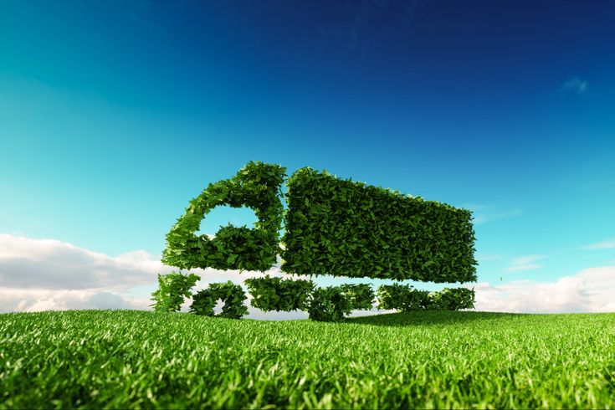




Fig 23: showing the transformation from traditional supply chain to green sc.
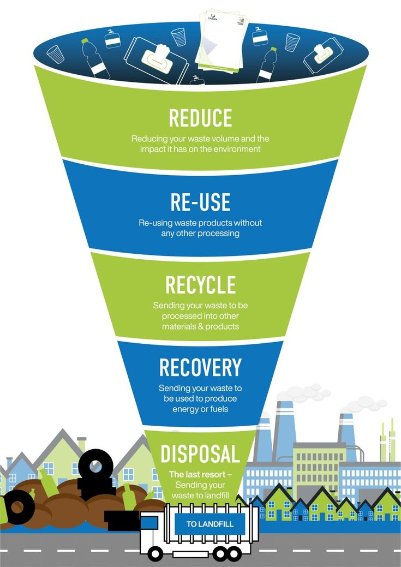

Fig 24: Showing the 4R process AL is practising

- Benefits to Ashok Leyland and Its Suppliers through Biodiversity Risk Assessment:

- Environment stewardship and compliance: The biodiversity risk assessments conducted by Ashok Leyland demonstrate that its developments and its operations and supply chain are conforming to standards and regulations around the world. Outside of complying with local laws, this is an important step towards conserving the environment and would limit the risk of compliance issues that may lead to fines or penalties.
- Sustainable Supply Chain Operations: Biodiversity assessments help identify environmentally sensitive areas, enabling AL and its suppliers to plan operations that avoid or mitigate ecological impact. This enhances sustainability across the supply chain and builds long-term operational credibility.
- Improved Brand Image and Market Advantage: Demonstrating a commitment to biodiversity through rigorous assessments positions AL as an environmentally responsible leader in the automotive and manufacturing sector. This can enhance brand reputation and attract eco-conscious investors, customers, and partners.
- Strengthened Supplier Engagement and Capacity Building: Engaging suppliers in biodiversity risk assessments promotes shared responsibility and helps build supplier capacity in environmental best practices.
- Enhanced Risk Mitigation: Identifying biodiversity-related risks in advance allows AL to implement targeted mitigation strategies, reducing the likelihood of disruptions due to environmental constraints.

Discussions:
The biodiversity risk assessment conducted on Ashok Leyland’s Hosur units has determined a moderate-high ranking of species richness, and an even level of species evenness based on the Shannon-Wiener Index outcomes which relates to both richness and relative abundance as documented by Nolan and even Callahan (2006). The presence of so many floral and faunal species, including several Schedule I and II species under the Wildlife Protection Act (1972 with 2022 amendments), suggests that the area retains a fair amount of ecological integrity. The importance of (frequency, abundance and density) as indicators of community composition, was supported with the similar findings of the quadrat-based assessment conducted Mahajan and Fatima (2017).
The evenness observed indicated some support to the proposed hypothesis that a heterogeneous industrial landscape produced with proper management (Mulder et al, 2004 found a positive association between species evenness delineation and ecosystem productivity) could retain measurable footing of biodiversity. Limitations of the study included seasonal limitations for sampling, species identification and general under-recording of nocturnal and cryptic species or threats in species abundance estimation models as referenced by Melville and Welsh. The biodiversity risk assessment undertaken during the internship at Ashok Leyland has advanced the integration of ecological considerations into the company's operational and strategic planning. This effort is focused on identifying, assessing, and managing biodiversity-related risks across selected sites within the selected jurisdictions with the aim of aligning the company's growth with sustainable environmental practices.
Next, the TNFD (2023) LEAP framework assisted in identifying vital dependencies and risks, providing a systematic understanding of the findings, which were aligned with nature-related financial disclosures. The study used robust methodology, including both quadrat and line transect techniques (Owusu, 2019) to assess and measure biodiversity loss, but key environmental drivers such as hydrological stress and habitat disturbance are important contributors to biodiversity loss. These results demonstrate the need for adaptive, local conservation strategies that are in accordance with global standards (e.g. GRI 101 - 2024).
Using an integrated approach that included site observations, quadrat sampling, land use mapping and literature survey the biodiversity assessment has provided valuable information regarding species richness, habitat conditions and key industrial threats to biodiversity. GIS based tools and "spatial analysis" were employed to identify ecologically sensitive areas and overlapping zones with operational or planned expansion sites.
This evidence-based assessment will proactively aid decision-making based on ecological realities. One of the major outcomes of the assessment was a clear identification of areas of high conservation value, such as patches of native vegetation, waterbodies, and areas used for pollinator or native plant/animal maintenance purposes. These findings crystallised the need for site-based mitigation measures, such as buffer zone, Miyawaki plantation where appropriate, or limited activity zones in sensitive areas.

The assessment also helped identify unknowns in current monitoring systems and supported the importance of continuous ecological assessments to detect changes over time. It established a foundation for the establishment of a baseline on biodiversity from which impacts of future developments or interventions could be evaluated against. It should be noted this assessment also supported Ashok Leyland to put into its supplier code of conduct and procurement framework, the importance of including biodiversity risks into its values and practices. There is an untapped opportunity to further engage suppliers on environmental responsibilities and enhance nature positive commitments through the use of the supply chain to further embed AL's sustainability aspirations.
In summary, while the biodiversity assessment improved Ashok Leyland's environmental profile it also provides a model for future assessments of a replicable nature. This will support long-term ecological continuum, restoration and integrity of habitats and inform the resulting sustainability objectives of the organization by operating in a responsible data-driven manner.
To enhance biodiversity resilience, Ashok Leyland needs to bolster long-term ecological monitoring, embrace community conservation practices, and employ mitigation actions such as developing greenbelts and habitat restoration. Using information from tools such as the WWF Risk Filter will also improve proactive risk management and sustainability planning. If Ashok Leyland can strategically focus on restoring native species and minimizing their operational impacts, they can achieve a more ecologically balanced setting and also remain compliant with their regulatory obligations. More broadly, this assessment has already satisfied its academic and regulatory obligation but is also an initial guide for Ashok Leyland’s future biodiversity stewardship and nature-positive trajectory.
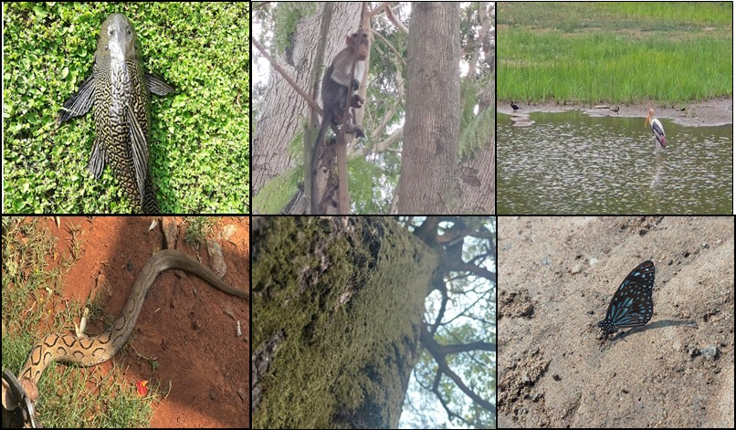

Fig 25: Some snippets taken during data collection

Conclusion
The Ashok Leyland Hosur Units I and II biodiversity risk assessment illustrates a forward-thinking, data-driven model of environmental responsibility. Situated in an area of moderate to high species richness, with an abundance of Schedule I and II fauna and the presence of IUCN-listed flora, the corporation has demonstrated a robust commitment to biodiversity conservation. Strict adherence to international frameworks such as the Taskforce on Nature-related Financial Disclosures (TNFD) and the WWF Biodiversity Risk Filter further reinforces Ashok Leyland’s dedication to integrating nature-related risks into corporate strategy. While certain ecological risks have been identified, the implementation of targeted mitigation measures, such as greenbelt development, habitat restoration, and native species plantation, positions the company to effectively manage its biodiversity footprint. Moving forward, continued ecological monitoring, stakeholder engagement, and periodic reassessment will be crucial to tracking progress and adapting interventions. Furthermore, embedding biodiversity indicators into enterprise-level decision-making and supply chain policies will ensure that conservation is not treated in isolation but is ingrained in operational culture. Ashok Leyland remains firmly committed to achieving its 2030 net positive biodiversity impact goal, aligning its practices with national biodiversity mandates and global sustainability standards to create lasting ecological value.



Reference
Mulder, C. P. H., Bazeley-White, E., Dimitrakopoulos, P. G., Hector, A., Scherer-Lorenzen, M., & Schmid, B. (2004). Species evenness and productivity in experimental plant communities. Oikos, 107(1), 50–63.
Nolan, K. A., & Callahan, J. E. (2006). Beachcomber biology: The Shannon-Weiner species diversity index. In M. A. O'Donnell (Ed.), Tested studies for laboratory teaching, Volume 27 (pp. 334–338). Proceedings of the 27th Workshop/Conference of the Association for Biology Laboratory Education (ABLE).
Melville, G. J., & Welsh, A. H. (n.d.). Estimating species abundance. In Biometrics - Vol. I. Encyclopedia of Life Support Systems (EOLSS), UNESCO. Retrieved from https://www.eolss.net/ebooklib/sc_cart.aspx?File=E4-31-01-05
Owusu, B. (2019). An introduction to line transect sampling and its applications. Department of Mathematical Sciences, Montana State University.
The McGraw-Hill Companies. (n.d.). Community diversity: Controls and patterns.
National Council of Educational Research and Training (NCERT). (2006). Laboratory manual: Biology (Class XII). New Delhi: NCERT.
Taskforce on Nature-related Financial Disclosures. (2023). Glossary of key terms: Version 1.0. TNFD.global.
Acharja, I. P., Tobgay, T., Gurung, D. B., Lungten, L., & Phuntsho, S. (2022). Biodiversity report: A rapid biodiversity assessment in White-bellied Heron habitats along Punatsangchhu and Mangdechhu basins, Bhutan. Royal Society for Protection of Nature.
Taskforce on Nature-related Financial Disclosures. (2023). Guidance on the identification and assessment of nature-related issues: The LEAP approach (Version 1.1). TNFD.global.
India. (1972). The Wild Life (Protection) Act, 1972 (amendment 2022).
Global Reporting Initiative. (2024). GRI 101: Biodiversity 2024. GRI Standards.
Mahajan, M., & Fatima, S. (2017). Frequency, abundance and density of plant species by list count quadrat method. Epitome: International Journal of Multidisciplinary Research, 3(7), 21–28.

Links:
https://www.iucnredlist.org/
https://www.globalforestwatch.org/
https://www.ibat-alliance.org/
https://www.inaturalist.org/

Annexure

Acronyms:
WWF - Worldwide fund for nature
KBA - Key biodiversity area
BRF - Biodiversity risk filter
WRF – Water risk filter
TNFD - Taskforce on nature related financial disclosure
GRI - Global reporting initiatives
LEAP - Locate, Evaluate, Assess, Prepare
IBAT - Integrated biodiversity assessment tool
IUCN - International union for conservation of nature

Definitions:
Biodiversity: The Biological Diversity Act, 2002 born out of the United Nations (CBD) 1992 define biodiversity as the variability among living organisms from all sources and the ecological complexes of which they are part and includes diversity within species or between species and of ecosystems.
Biodiversity risk: Potential threats posed to an organisation linked to its and other organisations impacts on biodiversity and dependencies on ecosystems. These can derive from physical, transition and systemic risks.
Dependencies on biodiversity: Aspects of ecosystem services that an organisation or other actor relies on to function. An organisation might be dependent upon an ecosystem’s regulation of water flow and quality, the resilience it provides against hazards like fires and floods, the pollination of crops it enables by providing a suitable habitat for pollinators, or its provision of timber or fibres.
Ecosystem: A dynamic complex of plant, animal and microorganism communities and their non-living environment, interacting as a functional unit.
Ecosystem services: The contributions of ecosystems to the benefits that are used in economic and other human activity. It constitutes three services Provisioning, regulating and cultural services.
Biodiversity offsets: Biodiversity offsets are measurable conservation outcomes resulting from actions designed to compensate for significant residual adverse biodiversity impacts arising from project development after appropriate prevention and mitigation measures have been taken. The goal of biodiversity offsets is to achieve no net loss and preferably a net gain of biodiversity on the ground with respect to species composition, habitat structure and ecosystem function and people’s use and cultural values associated with biodiversity.
Deforestation: The conversion of forest to other land use independently of whether human-induced or not. Which includes permanent reduction of the tree canopy cover below the minimum 10% threshold.
Habitat: The area, characterised by its abiotic and biotic properties, that is habitable by a particular species.
Invasive alien species: Species whose introduction and/or spread by human action outside their natural distribution threatens biological diversity, food security, and human health and well-being.
Density: Density represents the numerical strength of a certain species in the community per unit area. The number of individuals of the species in any unit area is its density.
Frequency: Frequency is concerned with the degree of uniformity of the occurrence of individuals of a species within a community. It is measured by noting the presence of a species in random sample areas (quadrats) which are distributed as widely as possible throughout the area of study.
Quadrat: A quadrat is a frame that is laid down to mark out a specific area of the community to be sampled. Within the quadrat frame, the occurrence of plants is recorded using an appropriate measure of abundance in square, rectangle or circular shape based on the site in which the assessment is going on.
Species richness: The number of species occupying a particular area or biological entity (such as a branch of a tree) without regard to any other properties of the species. Species richness may also be expressed as the list of species that generates that number.
Species evenness: Species evenness measures how similar the abundance of each species is within a community. It tells us how evenly the individuals are distributed among the different species present.
Transect line: A transect line is a linear path laid out spanning a study area, along which ecological observation is systematically acquired. It serves as a roadmap for sampling, allowing researchers to scrutinize and document the existence, distribution, and abundance of organisms.
Flora: A flora is a systematic enumeration of the plant species occurring in a given region. Flora may contain anything from a simple list of the plants occurring in an area to a very detailed account of those plants.
Fauna: Zoologists and palaeontologists use fauna to refer to a typical collection of animals found in a specific time or place.
Ecological Baseline: To understand the current ecological condition before it changes further and from which in near future, we can also use it as a reference point for near environmental impact.
Ecosystem integrity: It is the degree to which an ecosystem’s composition, structure, and function are similar to its natural or reference state.

Some species found inside both the plants:

Tree Species | IUCN List | Native status
Alstonia Scholaris | Least Concern(LC) | Native
Alstonia Macrophylla | Least Concern(LC) | Exotic
Bauhinia Racemosa | Least Concern(LC) | Native
Aegle marmelos | Near Threatened(NT) | Native
Terminalia Arjuna | Least Concern(LC) | Native
Cassia Javanica | Least Concern(LC) | Exotic
Azadirachta Indica | Least Concern(LC) | Native
Murraya Koenigii | Least Concern(LC) | Native
Ficus benghalensis | Not Evaluated(NE) | Native
Nyctanthes Arbor tristes | Least Concern(LC) | Native
madhuca longifolea | Least Concern(LC) | Native
Thespesia populnea | Least Concern(LC) | Native
Calophyllum inpophyllum | Least Concern(LC) | Native
Dalbergia Sissoo | Least Concern(LC) | Native
Mangifera indica | Data Deficient(DD) | Native
Swietenia Macrophylla | Endangerd (EN) | Exotic
Pongamia pinnata | Least Concern(LC) | Native
Neolamarckia Cadamba | Not Evaluated(NE) | Native
Ficus Carica | Least Concern(LC) | Exotic
Ficus Religiosa | Least Concern(LC) | Native
Mimusops Elengi | Least Concern(LC) | Native
Caryota Mitis | Least Concern(LC) | Exotic
Tabebuia Rosea | Least Concern(LC) | Exotic
Lucaena Luecacephala | Not Evaluated(NE) | Exotic
Saraca Asoka | Vulnerable(VU) | Native

Flowering Plant | IUCN List | Native status
Ixora | Not Evaluated(NE) | Native
Hymenocallis littoralis | Not Evaluated(NE) | Exotic
Eranthemum | Least Concern(LC) | Native
Duranta Erecta | Least Concern(LC) | Exotic
Cordia Sebestena | Least Concern(LC) | Exotic
Catharanthus Roseus | Not Evaluated(NE) | Exotic
Tagetes Erecta | Least Concern(LC) | Exotic
Geranium | Least Concern(LC) | Native
Nerium indicum | Least Concern(LC) | Native
Tabernaemontana divaricata | Least Concern(LC) | Exotic
Ruellia Simplex | Not Evaluated(NE) | Exotic
Tecoma Stans | Least Concern(LC) | Exotic
Jasminum Sambac | Not Evaluated(NE) | Native
Bougainvillea Glabra | Least Concern(LC) | Exotic
Canna indica | Not Evaluated(NE) | Exotic

Herb Species | IUCN List | Native status
Syngonium Podophyllum | Not Evaluated(NE) | Exotic
Mimosa Pudica | Least Concern(LC) | Exotic
Tradescantia Spathacea | Not Evaluated(NE) | Exotic
Laportea aestuans | Not Evaluated(NE) | Native

Shrubs | IUCN list | Native status
Codiaeum variegatum | Not Evaluated(NE) | Exotic
Acalypha Wilkesiana | Least Concern(LC) | Exotic
Duranta Repens | Least Concern(LC) | Exotic
Dracaena reflexa | Least Concern(LC) | Exotic
Hamelia Patens | Least Concern(LC) | Exotic
Ziziphus Obtusifolia | Least Concern(LC) | Exotic
leucophyllum Frutescens | Not Evaluated(NE) | Exotic
Fatsia Japonica | Near Threatened(NT) | Exotic

Weeds | IUCN list | Native status
Lantana Camara | Not Evaluated(NE) | Exotic
Chromolaena odorata | Not Evaluated(NE) | Exotic
Calotropis procera | Least Concern(LC) | Exotic
Digitaria sanguinalis | Least Concern(LC) | Exotic
Trifolium Repens | Least Concern(LC) | Exotic
Rottboellia | Least Concern(LC) | Exotic
Paspalum Notatum | Not Evaluated(NE) | Exotic
Cardiospermum Halicacabum | Least Concern(LC) | Native
limnophila Aromatica | Data Deficient(DD) | Native
Cyperus Rotundus | Least Concern(LC) | Native
Paspalum Repens | Least Concern(LC) | Exotic
Parthenium Hysterophorus | Not Evaluated(NE) | Exotic
Evolvulus Nummularius | Not Evaluated(NE) | Exotic
Dichanthelium Clandestinum | Not Evaluated(NE) | Exotic
Echinochloa Colona | Least Concern(LC) | Native
Oxalis Corniculata | Not Evaluated(NE) | Native
Sorghum Halepense | Not Evaluated(NE) | Native
Sphagneticola Trilobata | Not Evaluated(NE) | Exotic

Medicinal plant | IUCN List | Native status
Aloe Barbadensis Miller | Not Evaluated(NE) | Exotic
Lycopus Virginicus | Least Concern(LC) | Exotic
Justicia Adhatoda | Least Concern(LC) | Native
Kedrostis foetidissima | Least Concern(LC) | Exotic
Asparagus Racemosus | Not Evaluated(NE) | Native
Bacopa monnieri | Least Concern(LC) | Native
Wedelia Chinensis | Least Concern(LC) | Native
Tinospora Cordifolia | Not Evaluated(NE) | Native
Chlorophytum borivilianum | Critically Endangered(CR) | Native

Fruiting plant | IUCN List | Native status
Annona Muricata | Least Concern(LC) | Exotic
Manilkara Zapota | Least Concern(LC) | Exotic
Citrus Limon | Least Concern(LC) | Native
Annona Squamosa | Least Concern(LC) | Exotic
Morinda Citrifolia | Least Concern(LC) | Native
Punica Granatum | Least Concern(LC) | Native
Malpighia Emarginata | Data Deficient(DD) | Exotic
Citrus Limetta | Not Evaluated(NE) | Native
Syzygium Malaccense | Least Concern(LC) | Exotic
Citrus Aurantiifolia | Not Evaluated(NE) | Native
Citrus Sinensis | Not Evaluated(NE) | Exotic
Eugenia Uniflora | Least Concern(LC) | Exotic
Artocarpus Altilis | Not Evaluated(NE) | Exotic
Table 10: showing classification of some species for demonstration through IUCN status & Nativity status.

Fauna species:
Scientific Name | Class | Phylum | WPA Schedule
Microcarbo niger | Aves | Chordata | Schedule II(b)
Anas poecilorhyncha | Aves | Chordata | Schedule II(b)
Nycticorax nycticorax | Aves | Chordata | Schedule II(b)
Alcedo atthis | Aves | Chordata | Schedule II(b)
Tor tor | Pisces | Chordata | Schedule I(a)
Junonia iphita | Insecta | Arthropoda | N/L
Eurema hecabe | Insecta | Arthropoda | N/L
Hasora chromus | Insecta | Arthropoda | N/L
Euploea core | Insecta | Arthropoda | N/L
Eurema andersoni | Insecta | Arthropoda | Schedule II(h)
Pseudozizeeria maha | Insecta | Arthropoda | N/L
Phlogophora meticulosa | Insecta | Arthropoda | N/L
Hierodula membranacea | Insecta | Arthropoda | N/L
Deroplatys desiccata | Insecta | Arthropoda | N/L
Funambulus palmarum | Mammalia | Chordata | N/L
Sceliphron caementarium | Insecta | Arthropoda | N/L
Haliastur indus | Aves | Chordata | Schedule I(b)
Oryctolagus cuniculus | Mammalia | Chordata | N/L
Catopsilia pomona | Insecta | Arthropoda | N/L
Psittacula krameri | Aves | Chordata | Schedule II(b)
Orthetrum caledonicum | Insecta | Arthropoda | N/L
Cornu aspersum | Gastropoda | Mollusca | N/L
Ardea alba | Aves | Chordata | Schedule II(b)
Calotes versicolor | Reptilia | Chordata | N/L
Copsychus saularis | Aves | Chordata | Schedule II(b)
Trimeresurus malabaricus | Reptilia | Chordata | Schedule II(c)
Ortigornis pondicerianus | Aves | Chordata | Schedule II(b)
Ardea purpurea | Aves | Chordata | Schedule II(b)
Oniscus asellus | Malacostraca | Arthropoda | N/L
Oecanthus niveus | Insecta | Arthropoda | N/L
Ardea cinerea | Aves | Chordata | Schedule II(b)
Pavo cristatus | Aves | Chordata | Schedule I(b)
Copsychus fulicatus | Aves | Chordata | Schedule II(b)
Milvus migrans | Aves | Chordata | Schedule II(b)
Prinia socialis | Aves | Chordata | Schedule II(b)
Centropus sinensis | Aves | Chordata | Schedule II(b)
Pycnonotus cafer | Aves | Chordata | Schedule II(b)
Spilopelia chinensis | Aves | Chordata | Schedule II(b)
Dicrurus macrocercus | Aves | Chordata | Schedule II(b)
Vanellus indicus | Aves | Chordata | Schedule II(b)
Ardeola grayii | Aves | Chordata | Schedule II(b)
Merops orientalis | Aves | Chordata | Schedule II(b)
Cecropis daurica | Aves | Chordata | Schedule II(b)
Dicaeum erythrorhynchos | Aves | Chordata | Schedule II(b)
Corvus macrorhynchos | Aves | Chordata | Schedule II(b)
Sus scrofa | Mammalia | Chordata | N/L
Melanochelys trijuga | Reptilia | Chordata | Schedule I(c)
Clarias batrachus | Pisces | Chordata | N/L
Daboia russelii | Reptilia | Chordata | Schedule I(c)
Ptyas mucosa | Reptilia | Chordata | Schedule I(c)
Python molurus | Reptilia | Chordata | Schedule I(c)
Amphiesma stolatum | Reptilia | Chordata | Schedule II(c)
Funambulus palmarum | Mammalia | Chordata | N/L
Duttaphrynus melanostictus | Amphibia | Chordata | N/L
Amaurornis phoenicurus | Aves | Chordata | Schedule II(b)
Drosophila melanogaster | Insecta | Arthropoda | N/L
Halyomorpha halys | Insecta | Arthropoda | N/L
Ocybadistes walkeri | Insecta | Arthropoda | N/L
Oecophylla smaragdina | Insecta | Arthropoda | N/L
Euchrysops cnejus | Insecta | Arthropoda | N/L
Acytolepis puspa | Insecta | Arthropoda | N/L
Amata phegea | Insecta | Arthropoda | N/L
Apis dorsata | Insecta | Arthropoda | N/L
Junonia almana | Insecta | Arthropoda | N/L
Macaca radiata | Mammalia | Chordata | Schedule I(a)
Tirumala limniace | Insecta | Arthropoda | N/L
Acraea terpsichore | Insecta | Arthropoda | N/L
Columba livia | Aves | Chordata | N/L
Egretta garzetta | Aves | Chordata | Schedule II(b)
Danaus chrysippus | Insecta | Arthropoda | N/L
Oenanthe fusca | Aves | Chordata | N/L
Anser anser domesticus | Aves | Chordata | N/L
Bubulcus ibis | Aves | Chordata | Schedule II(b)
Pachliopta hector | Insecta | Arthropoda | Schedule II(h)
Pavo cristatus | Aves | Chordata | Schedule I(b)
Motacilla maderaspatensis | Aves | Chordata | Schedule II(b)
Corvus splendens | Aves | Chordata | N/L
Blattodea (order) | Insecta | Arthropoda | N/L
Pediculus humanus | Insecta | Arthropoda | N/L
Mycteria leucocephala | Aves | Chordata | Schedule II(b)
Bufo bufo | Amphibia | Chordata | N/L
Oxya japonica | Insecta | Arthropoda | N/L
Prinia inornata | Aves | Chordata | Schedule II(b)
Coracias benghalensis | Aves | Chordata | Schedule II(b)
Plocealauda affinis | Aves | Chordata | Schedule II(b)
Tachyspiza badius | Aves | Chordata | Schedule I(b)
Zosterops palpebrosus | Aves | Chordata | Schedule II(b)
Aegithina tiphia | Aves | Chordata | Schedule II(b)
Argya affinis | Aves | Chordata | Schedule II(b)
Acridotheres tristis | Aves | Chordata | Schedule II(b)
Pycnonotus jocosus | Aves | Chordata | Schedule II(b)
Trachelipus rathkii | Malacostraca | Arthropoda | N/L
Psilopogon viridis | Aves | Chordata | Schedule II(b)
Eudynamys scolopaceus | Aves | Chordata | Schedule II(b)
Saxicola caprata | Aves | Chordata | Schedule II(b)
Halcyon smyrnensis | Aves | Chordata | Schedule II(b)
Leptocoma zeylonica | Aves | Chordata | Schedule II(b)
Cinnyris asiaticus | Aves | Chordata | Schedule II(b)
Orthotomus sutorius | Aves | Chordata | Schedule II(b)
Psilopogon haemacephalus | Aves | Chordata | Schedule II(b)
Acridotheres fuscus | Aves | Chordata | Schedule II(b)
Tachybaptus ruficollis | Aves | Chordata | Schedule II(b)
Vulpes bengalensis | Mammalia | Chordata | Schedule I(a)
Tibellus oblongus | Arachnida | Arthropoda | N/L
Oligodon arnensis | Reptilia | Chordata | N/L
Salticus spp. | Arachnida | Arthropoda | N/L
Pterygoplichthys pardalis | Pisces | Chordata | N/L
Ophiophagus hannah | Reptilia | Chordata | Schedule I(c)
Bungarus caeruleus | Reptilia | Chordata | Schedule II(c)
Bungarus fasciatus | Reptilia | Chordata | Schedule II(c)
Naja naja | Reptilia | Chordata | Schedule I(c)
Ophiusa parcemacula | Insecta | Arthropoda | N/L
Cryptotermes domesticus | Insecta | Arthropoda | N/L
Talicada nyseus | Insecta | Arthropoda | N/L
Diplacodes trivialis | Insecta | Arthropoda | N/L
Camponotus compressus | Insecta | Arthropoda | N/L
Agriocnemis pygmaea | Insecta | Arthropoda | N/L
Urva edwardsii | Mammalia | Chordata | Schedule I(a)
Scutellera nobilis | Insecta | Arthropoda | N/L
Daboia russelii | Reptilia | Chordata | Schedule I(c)
Argiope anasuja | Arachnida | Arthropoda | N/L
Tetragonula iridipennis | Insecta | Arthropoda | N/L
Purana tigrina | Insecta | Arthropoda | N/L
Papilio polytes | Insecta | Arthropoda | N/L
Ropalidia marginata | Insecta | Arthropoda | N/L
Penthicodes variegata | Insecta | Arthropoda | N/L
Psammophilus dorsalis | Reptilia | Chordata | N/L
Papilio demoleus | Insecta | Arthropoda | N/L
Clavigralla gibbosa | Insecta | Arthropoda | N/L
Subulina octona | Gastropoda | Mollusca | N/L
Apis cerana indica | Insecta | Arthropoda | N/L
Elattoneura nigerrima | Insecta | Arthropoda | N/L
Acheta domesticus | Insecta | Arthropoda | N/L
Acanthaspis siva | Insecta | Arthropoda | N/L
Dermestidae (family) | Insecta | Arthropoda | N/L
Rumina decollata | Gastropoda | Mollusca | N/L
Lampito mauritii | Clitellata | Annelida | N/L
Hypochrosis hyadaria | Insecta | Arthropoda | N/L
Carausius morosus | Insecta | Arthropoda | N/L
Bipalium kewense | Turbellaria | Platyhelminthes | N/L
Archaeognatha | Insecta | Arthropoda | N/L
Belenois aurota | Insecta | Arthropoda | N/L
Eurema andersoni | Insecta | Arthropoda | Schedule II(h)
Oryctolagus cuniculus | Mammalia | Chordata | N/L
Accipiter badius | Aves | Chordata | Schedule I(b)
Nephotettix nigropictus | Insecta | Arthropoda | N/L
Everes lacturnus | Insecta | Arthropoda | N/L
Papilio demoleus | Insecta | Arthropoda | N/L
Aspidimorpha miliaris | Insecta | Arthropoda | N/L
Scarabaeus sacer | Insecta | Arthropoda | N/L
Calotes versicolor | Reptilia | Chordata | N/L
Ocyceros birostris | Aves | Chordata | Schedule II(b)
Psittacula eupatria | Aves | Chordata | Schedule II(b)
Athene brama | Aves | Chordata | Schedule II(b)
Coelognathus helena | Reptilia | Chordata | N/L
Fowlea piscator | Reptilia | Chordata | Schedule I(c)
Zizina labradus | Insecta | Arthropoda | N/L
Tringa ochropus | Aves | Chordata | Schedule II(b)
Pseudibis papillosa | Aves | Chordata | Schedule II(b)
Anoplolepis gracilipes | Insecta | Arthropoda | N/L
Coccinella transversalis | Insecta | Arthropoda | N/L
Pteropus medius | Mammalia | Chordata | Schedule II(a)
Pterophylla camellifolia | Insecta | Arthropoda | N/L
Pisaurina mira | Arachnida | Arthropoda | N/L
Arianta arbustorum | Gastropoda | Mollusca | N/L
Oreochromis mossambicus | Pisces | Chordata | N/L
Cyprinus carpio | Pisces | Chordata | N/L
Cyprinus rubrofuscus | Pisces | Chordata | N/L
Table 11: Showing faunal data according to WLPA,1972

Note: All these data are only for demonstration purpose, usage of this data anywhere else other than this report will be a copyright infringement.
            - Fauna data is classified as IUCN red list category
            - Fauna data is classified as WLPA,1972

Project charter:

Task Name | Start Date | End Date | Duration (in Days) | Adjusted length
Review Previous Biodiversity Reports | 15-04-2025 | 16-04-2025 | 1 | 1
Prepare Initial Gantt Chart | 16-04-2025 | 17-04-2025 | 1 | 1
Research & Analyze Suitable Tools & Techniques | 17-04-2025 | 18-04-2025 | 1 | 1
Plant Visit - Safety Briefing & Measures(H2) | 18-04-2025 | 21-04-2025 | 1 | 3
Initial Biodiversity Assessment of Plant Region(H2) | 21-04-2025 | 22-04-2025 | 1 | 1
Data Collection Planning(H2) | 22-04-2025 | 23-04-2025 | 1 | 1
Identify Key Biodiversity Indicators(H2) | 23-04-2025 | 24-04-2025 | 1 | 1
Develop Sampling Strategy(H2) | 24-04-2025 | 28-04-2025 | 2 | 4
Acquire key equipments/approvals for assessment | 28-04-2025 | 29-04-2025 | 1 | 1
Phase 1 - field data collection- flora(H2) | 29-04-2025 | 07-05-2025 | 6 | 8
Phase 2- field data collection- fauna(H2) | 07-05-2025 | 09-05-2025 | 2 | 2
Plant Visit - Safety Briefing & Measures(H1) | 09-05-2025 | 12-05-2025 | 1 | 3
Phase 1 - field data collection- flora(H1) | 12-05-2025 | 19-05-2025 | 5 | 7
Phase 2 - field data collection- fauna(H1) | 19-05-2025 | 21-05-2025 | 2 | 2
Phase 3: Detailed Biodiversity Analysis | 21-05-2025 | 23-05-2025 | 2 | 2
Identify Potential Biodiversity Risks in unit 1 & 2 | 23-05-2025 | 27-05-2025 | 2 | 4
Assess the Magnitude and Likelihood of Risks | 27-05-2025 | 29-05-2025 | 2 | 2
Develop Mitigation Strategies for Identified Risks | 29-05-2025 | 02-06-2025 | 2 | 4
Review and Refine Mitigation Strategies | 02-06-2025 | 04-06-2025 | 2 | 2
Prepare Draft Biodiversity Risk Assessment Report | 04-06-2025 | 12-06-2025 | 6 | 8
Internal Review of Draft Report | 12-06-2025 | 16-06-2025 | 2 | 4
Incorporate Feedback and Finalize Report | 16-06-2025 | 18-06-2025 | 2 | 2

Table 12: Showing Project plans & timeline

Gantt chart

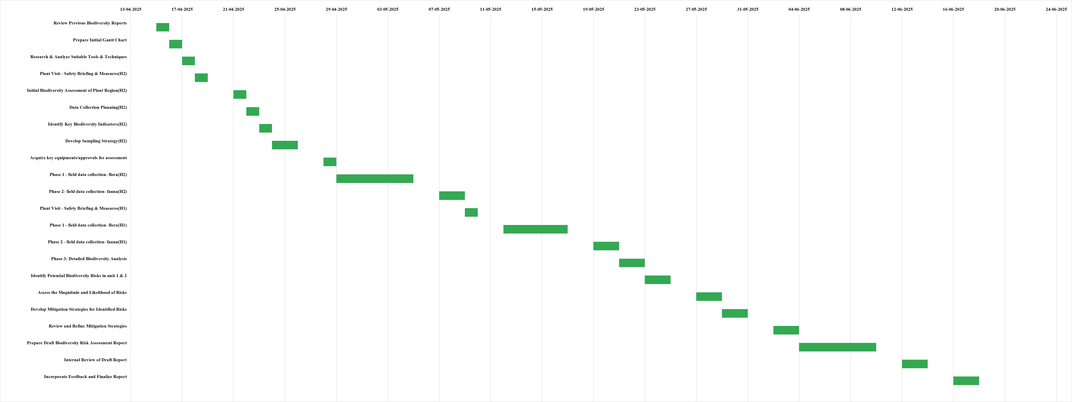

Key learnings and Takeaways:
Engaging in the biodiversity risk assessment endeavour at Ashok Leyland has been an incredibly valuable experience which has greatly enhanced my understanding of how industrial development and ecological responsibility intersect. In the course of the project, I gained a strong working understanding of biodiversity evaluation methods including quadrat sampling, species richness evaluation, and habitat integrity assessments. I also gained proficiency with spatial tools, including GIS mapping, and the WWF Biodiversity Risk Filter to identify ecologically sensitive areas for consideration regarding the impact of industrial activity on local flora and fauna.
This experience enhanced my understanding of nationally mandated biodiversity obligations and global frameworks such as the Taskforce on Nature-related Financial Disclosures (TNFD), the IUCN No Net Loss Principle, and extended producer responsibility (EPR). I learned to contextualise and integrate environmental data into corporate risk profiles, to identify key areas for mitigation, conservation, and restoration action.
Additionally, the project enhanced my analytical and reporting capabilities, particularly to prepare actionable recommendations for sustainable land-use planning, supplier compliance and greenbelt establishment. Most importantly, it deepened my understanding of the importance of harmonising corporate growth with ecological balance, specifically how biodiversity sufficient strategies can contribute a resilient, responsible, and future-ready industrial ecology.
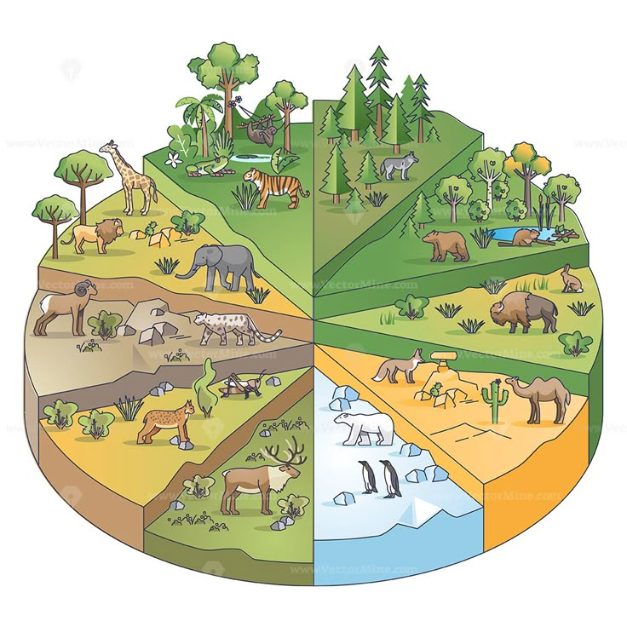

“Biodiversity is the heartbeat of the Earth- silent, vital, and irreplaceable. Protecting it is preserving the balance of life itself.”

Disclaimer: This report has been submitted as part of the academic and institutional requirements of the Indian Institute of Forest Management (IIFM), Bhopal. Upon submission, the contents, data and intellectual property herein are considered the property of IIFM. Any reproduction, distribution, or use of this report or its findings, in whole or in part, without prior written permission from IIFM, is strictly prohibited. The views expressed in this report are those of the author (Radha Krishna Jha) and do not necessarily reflect the official policy or position of IIFM.





“END OF THE REPORT”

https://www.ashokleyland.com/
https://www.indiacode.nic.in/bitstream/123456789/2046/4/a2003-18.pdf
https://cdn.kettufy.io/prod-fra-1.kettufy.io/documents/riskfilter.org/WWF_TacklingBiodiversityRisk.pdf (This source applies to second and third definition above)
Convention on biological diversity, Article 2, 1992, IPBES
(UN, 2021). TNFD (2022c)
https://www.forest-trends.org/wp-content/uploads/imported/bbop_updated_glossary_6-july-12_v1-pdf.pdf
FAO (2020)
Keith, D. et al (2020) IUCN Global Ecosystem Typology 2.0: Descriptive Profiles for Biomes and Ecosystem Functional Groups
Intergovernmental Science-Policy Platform on Biodiversity and Ecosystem Services (IPBES Glossary)
NCERT
file:///C:/Users/radhakrishna/Downloads/Quadrat-sampling.pdf
Kiester A. Ross (2013) Species Diversity, Overview. In: Levin S.A. (ed.) Encyclopaedia of Biodiversity, second edition, Volume 6, pp. 706-714
https://bsi.gov.in/page/en/flora
Ecosystem integrity

